NAME OR EVENT | GRADE 1 TO 3 | GRADE 4 TO 6 | GRADE 7 TO 8
Galen | I can name 3 facts about them | I can compare link them to an event or another important person. | I can explain the short term and long term impacts that they had.
Hippocrates | I can name 3 facts about them | I can compare link them to an event or another important person. | I can explain the short term and long term impacts that they had.
Vesalius | I can name 3 facts about them | I can compare link them to an event or another important person. | I can explain the short term and long term impacts that they had.
Pare | I can name 3 facts about them | I can compare link them to an event or another important person. | I can explain the short term and long term impacts that they had.
William Harvey | I can name 3 facts about them | I can compare link them to an event or another important person. | I can explain the short term and long term impacts that they had.
John Hunter | I can name 3 facts about them | I can compare link them to an event or another important person. | I can explain the short term and long term impacts that they had.
Edward Jenner | I can name 3 facts about them | I can compare link them to an event or another important person. | I can explain the short term and long term impacts that they had.
Joseph Lister | I can name 3 facts about them | I can compare link them to an event or another important person. | I can explain the short term and long term impacts that they had.
Louis Pasteur | I can name 3 facts about them | I can compare link them to an event or another important person. | I can explain the short term and long term impacts that they had.
Robert Koch | I can name 2 facts about them | I can compare link them to an event or another important person. | I can explain the short term and long term impacts that they had.
John Snow | I can name 3 facts about them | I can compare link them to an event or another important person. | I can explain the short term and long term impacts that they had.
Paul Ehrlich | I can name 3 facts about them | I can compare link them to an event or another important person. | I can explain the short term and long term impacts that they had.
Alexander Fleming | I can name 2 facts about them | I can compare link them to an event or another important person. | I can explain the short term and long term impacts that they had.
Florey and Chain | I can name 3 facts about them | I can compare link them to an event or another important person. | I can explain the short term and long term impacts that they had.
Medieval Surgery | I can name 3 key facts or examples | I can link it to another event or key individual | I can explain the short term and long term impacts that it had.
19th century surgery | I can name 3 key facts or examples | I can link it to another event or key individual | I can explain the short term and long term impacts that it had.
Beliefs about disease in the medieval times | I can name 3 key facts or examples | I can link it to another event or key individual | I can explain the short term and long term impacts that it had.
Beliefs about disease in the Renaissance | I can name 3 key facts or examples | I can link it to another event or key individual | I can explain the short term and long term impacts that it had.
Key Renaissance events | I can name 3 key facts or examples | I can link it to another event or key individual | I can explain the short term and long term impacts that it had.
The Black Death | I can name 3 key facts or examples | I can link it to another event or key individual | I can explain the short term and long term impacts that it had.
The Great Plague | I can name 3 key facts or examples | I can link it to another event or key individual | I can explain the short term and long term impacts that it had.
Impact of WW1 | I can name 3 key facts or examples | I can link it to another event or key individual | I can explain the short term and long term impacts that it had.
Public Health in the medieval times | I can name 3 key facts or examples | I can link it to another event or key individual | I can explain the short term and long term impacts that it had.
Public Health in the 19th century | I can name 3 key facts or examples | I can link it to another event or key individual | I can explain the short term and long term impacts that it had.
Medieval Hospitals | I can name 3 key facts or examples | I can link it to another event or key individual | I can explain the short term and long term impacts that it had.
Public Health reforms | I can name 3 key facts or examples | I can link it to another event or key individual | I can explain the short term and long term impacts that it had.
Islamic Medicine | I can name 3 key facts or examples | I can link it to another event or key individual | I can explain the short term and long term impacts that it had.
Above are the basic key individuals and events that you should know for your medicine through time exam. You should aim to work your way through each potential grade boundary skill if you wish to attain the highest possible grade.
You should highlight each individual or event skill once you feel confident in it.
Below are examples of factors grids-Using your knowledge and revision packs you could create your own set of revision grids using the template as an example-you simply need to put between 1-2 examples in each box.

Examples for DISEASE | Chance | Religion | Government | Individual Genius | Science and technology | Communication | War
Medieval Times
Renaissance
Early Modern
Modern

Examples for SURGERY | Chance | Religion | Government | Individual Genius | Science and technology | Communication | War
Medieval Times
Renaissance
Early Modern
Modern

Examples for PUBLIC HEALTH | Chance | Religion | Government | Individual Genius | Science and technology | Communication | War
Medieval Times
Renaissance
Early Modern
Modern

An example list of mind maps you could create for Nazi Germany:
- Germany under the Kaiser
- Treaty of Versailles
- Weimar Republic Strengths
- Weimar Republic Weaknesses
- Hitler’s rise to power
- Life in Nazi Germany for specific groups
- Opposition and control in Nazi Germany.
Alternatively in medicine you could do a mind map for the different medicine factors; Science and technology, chance, government, war, individual genius, religion and communication.
For the Inter War years you could focus on the following points:
- The League of Nations
- Events in the 1920s
- The main international agreements
- Events in the 1930s
- Hitler takeover of different countries
- Main causes of war.
Alternatively for the Normans you could focus on; claims to the throne, the three main battles, your site study question, changes to towns and villages, changes to religion, changes to law and order, changes to landholding and the feudal system.

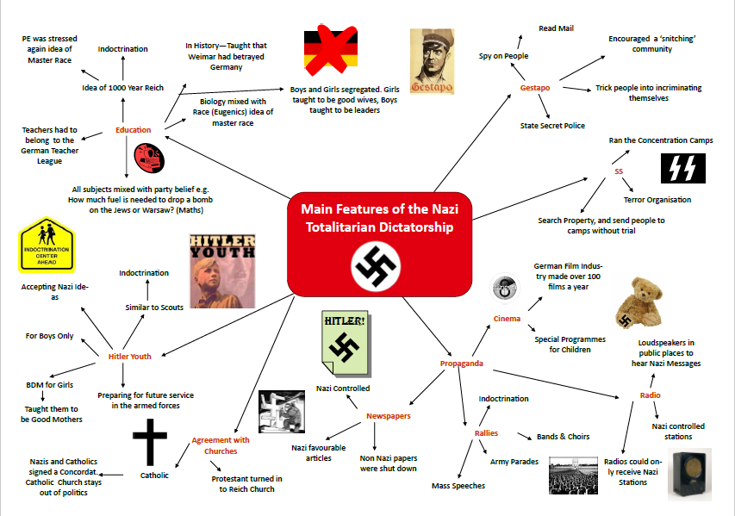
Alternatively you could try mind maps, above is an example for Nazi Germany which we study. You can use a combination of key words and heads to help you recall the most important parts. Mind maps help us to link key events together and remember the most important points to expand on later.

Time to take a walk down History Street

You are going to sit two history exams which are 2 hours long:
Paper 1: Germany and Inter War Years (1 hour each)
Paper 2: Health and the People and the Normans (1 hour each)
You are studying AQA GCSE HISTORY (8145)
Paper 1 Exam: Monday 1st June 2020
Paper 2 Exam: Thursday 4th June 2020

This guide is designed to give you the final steps to success in History ahead of your exams,

The Norman Conquest Websites
https://www.bbc.co.uk/bitesize/guides/zsjnb9q/revision/1
https://www.bbc.co.uk/bitesize/guides/zcmfk7h/revision/1
https://www.youtube.com/watch?v=1sK4JX0co8I

Germany and Democracy Websites
https://www.bbc.co.uk/bitesize/topics/zymqwxs
https://www.bbc.co.uk/bitesize/guides/zcwxrdm/revision/1
https://www.stpatricksrchigh.co.uk/documents/pupils/revision-information/year-11-revision-history-paper-1-section-a-germany-18901945.pdf?5ce7dbf3

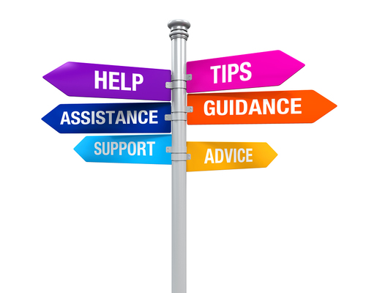
The Inter War Years Websites
https://www.bbc.co.uk/bitesize/topics/zmxmn39
https://www.sparknotes.com/history/european/interwaryears/
https://www.tes.com/teaching-resource/gcse-inter-war-years-revision-notes-6066834
Health and the People Websites
https://www.bbc.co.uk/bitesize/guides/zxg6wxs/revision/1
https://www.bbc.co.uk/bitesize/guides/zgdftyc/revision/1
http://thebicesterschool.org.uk/wp-content/uploads/2016/06/Medicine-Through-Time.pdf

Mr Townsend can provide:
- Exam technique advice
- Knowledge catch up sessions
- Revision Guides
- Practice exam papers
- Support and advice
Help is always there for those who seek it.
Every Monday, after school, there is a history intervention session led by Mr Townsend which runs for up to an hour. This intervention focuses on extra knowledge and exam skills which can get your grade up to another level.
Every half term Mr Townsend also runs an intervention day for you to come in and gain valuable help, support and advice.
In the build up to the actual exams, a warm up session will take place on the day of paper 1 and paper 2 for some last minute advice.
Mr Townsend’s door is always open so please come and see me if you need any help.

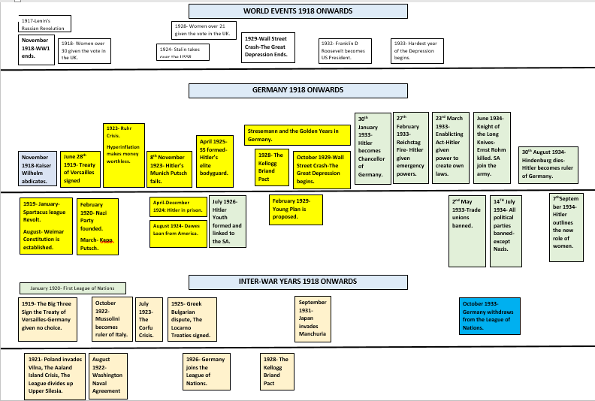
Timelines are another great way to see the big picture with history. Consider creating a timeline of all the key events for each topic-especially for Germany and the Inter War Years (Mr Townsend has examples you can add to).
Timelines can also be colour coded to show how certain events link together-this is important for all of your history events.

For example a medicine timeline could be colour coded to show examples of the different medicine factors.

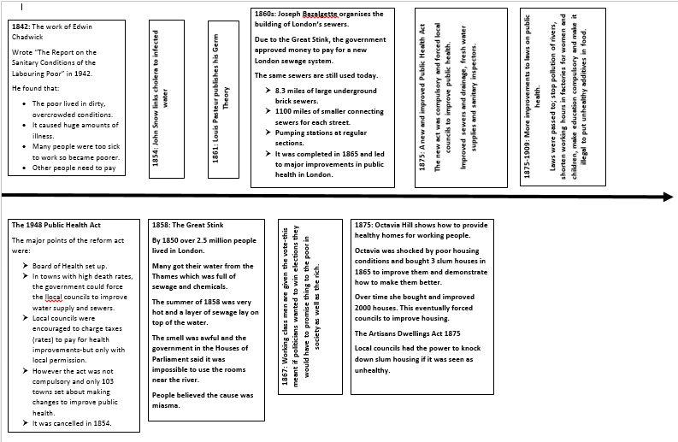

Flashcards are a great tool for remember key information and are simple to make. On one side you simply make basic bullet points about your history topics and on the reverse you add questions to ask yourself.
For the health and the people unit, I put my flashcards into themes; disease, public health and surgery. You could make similar flashcards based on Germany for themes such as; the Weimar Republic, Hitler’s rise to power and Life in Nazi Germany.
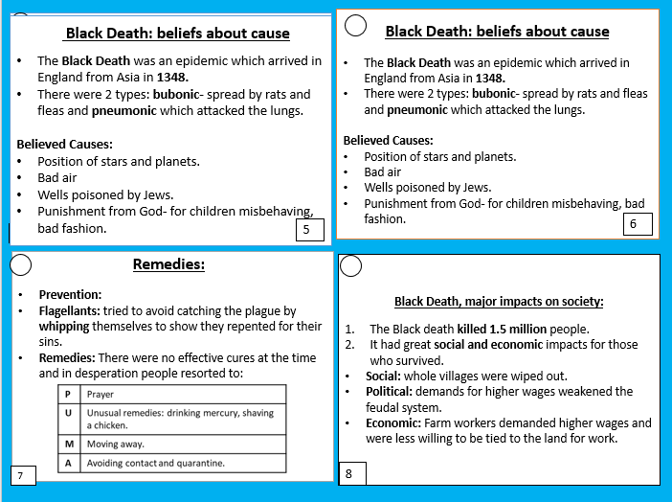
Remember to keep the notes on your flashcards simple-too many details will make it harder for you to remember your points.
Ask your friends and family to test you on the questions when you are ready.

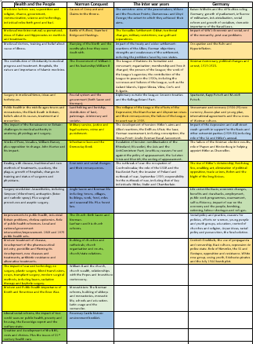
On the A3 sheet is everything that we have studied in the past 3 years in History-You should aim to revise as many of them as possible if you are going for a grade 7-9.

If you are aiming for a grade 4 or below then target only the key names and events we have studied.

If you are aiming between a grade 5 and 6 then you should look to learn the key names and events plus extra details.

Using images to show the key events in terms of a big picture is also a great way to revise. The example on the left covers Nazi Germany from the Kaiser Wilhelm up to Hitler becoming chancellor in 8 simple pictures.
You could use this method with any of our topics-for example with the Medicine topics you could use key faces or pictures of objects. Or for the Normans you could have a picture of battles or places.
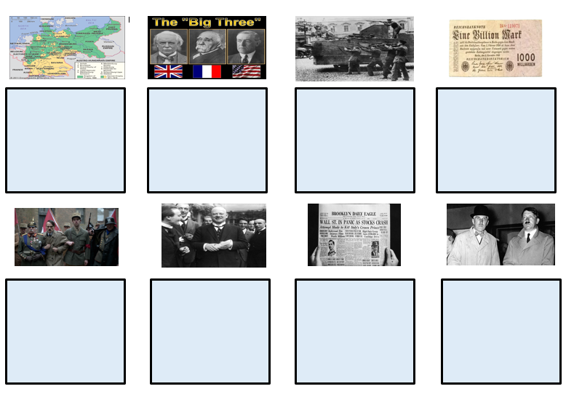
You might remember the example we did together in lesson where we drew on the tables to show links and details between all of the key events.

