 | Paper 2
Date: | 3rd June 2020
Length: | 1 hour 30 minutes
Time of day: | PM
Total number of marks: | 88  3 marks for SPaG
Equipment needed: | 2 black or blue pens  2 pencils  Ruler  Calculator
Topics covered: | Section A – Question 1: Urban issues and challenges – 33 marks – answer all questions  Section B – Question 2: The changing economic world -30 marks – answer all questions  Section C:  Answer Question 3 and question 6 (ENERGY) – 25 marks  Question types:  multiple-choice, short answers, 2 x 9 markers

Section A: Urban issues and challenges

The growing percentage of the world’s population lives in urban areas
The global pattern of urban change:
- High Income Countries are more economically developed e.g. UK.
- Urbanisation has happened here years ago during the industrial revolution so most people tend to live in urban areas.
- Low Income Countries are less economically developed e.g. Nepal and not many live in urban areas. Therefore the fastest rates of urbanisation are in LICs.
- Newly Emerging Economies are where economic development is increasing rapidly e.g. Brazil. Therefore urban growth is high here.
Why is this?
Richer countries - Rural to cities where urbanisation occurred in 18th and 19th Centuries when industrial and agricultural revolutions meant that machinery replaced farm labour.
More jobs were created in new factories in urban areas and people moved from farms to towns for work. In the late 20th Century people left run down inner city areas and moved to the country.
You are likely to get a graph question for this – please remember the magic formula!:
TREND (is the line increasing/decreasing/fluctuating)
DESCRIPTION (How quickly or slowly the line is increasing or decreasing)
DATA (Give some data to prove what you are talking about. Give the very first and the very last pieces of data)
SUM (Do some maths to work out the difference)

Factors affecting the rate of urbanisation:
Key words:
Urban sprawl/growth = Unplanned growth of urban areas which spread into rural areas
Urbanisation = is the increase in the proportion (%) of people living in urban (towns and cities) areas and a decrease in those living in rural (countryside) areas”
This is caused by
- Rural-urban migration = When people move from the countryside to the city due to push (war, drought, lack of food and poor healthcare) and pull factors (better healthcare, better education and more job opportunities).
- Natural Increase = More people having more babies. More babies are born in cities and more will move to cities.

The emergence of megacities (a city with more than 10 million people in it):
- There are currently 34 megacities.
- More than 2/3 of these are in LICs and NEEs.
- E.G. LA, Tokyo
- THEY GROW BECAUSE OF RURAL-URBAN MIGRATION AND NATURAL INCREASE.

Urban sustainability requires management of resources and transport
Key term:
- Sustainable city = A sustainable city is one that is designed to not impact the environment, use lots of renewable energy and not produce a lot of waste. They also want to reduce the amount of waste going to landfill.
Features of Sustainable cities:
WATER CONSERVATION  -Collect rainwater for toilets.  -Install water meters.  -Encourage people to use less water. | ENERGY CONSERVATION SCHEMES:  -Promote renewable energy  -Government incentives to make homes energy efficient e.g. putting solar panels on houses.  -Encourage people to be energy efficient.

CREATING GREEN SPACES:  -Encourage people to exercise more  -Make people feel happier  -Reduce flooding via reducing runoff  -Reduce air pollution | WASTE RECYCLING:  -Less waste into landfill  -Less co2 released  -Collect household recycling  -Websites e.g. Freecycle recycle items for free.
Examples:
SUSTAINABLE CITY = CURITIBA  Social Sustainability  - 26 parks for recreation and exercise. They are also sued as natural flood defences  - Pedestrianised areas  - 700 people moved out of the slums into good quality housing  - Recycling 5kg of rubbish for 1kg of fruit and veg and bus tickets – The Green Swap Programme. 70% of households do this.  Economic Sustainability  - There is an Industrial City 10 km West of the city, to provide jobs for its citizens.  - 200,000 new homes were built in the industrial zone so people could cycle to work  - 550 factories built to provide a range of jobs e.g. Volvo  - Cheap buses circulate the city and arrive every 60 seconds  Environmental Sustainability  - Sheep mow the 27 parks so petrol lawn mowers are not used  - Triple articulated buses come every 60 seconds which are used heavily in the city. They hold more passengers  - 1.5 million trees planted | SUSTAINABLE URBAN LIVING/COMMUNITY = BEDZED  Social sustainability  - 100 homes so people know each other  - The houses are affordable housing. This means you only pay what you can afford to pay for them, based on your wage  - Roof top gardens to grown organic fruit and veg with no chemicals  Economic sustainability  - 500m from the nearest train station so people can access their jobs  - 81% less heating so the bills are cheaper  - A rated appliance so they used less electricity meaning cheaper bills  Environmental sustainability  - Z Car Share Scheme. The cars run on electricity  - South facing homes so no need for heating  - 777m2 of solar panels  - Recycle rainwater for toilet water

How urban transport strategies are used to reduce traffic congestion
Traffic congestion is when there is a huge amount of cars on the road. It has increased because more people have more disposable income to afford cars and there are on average 2 cars per family.
ISSUES WITH CONGESTION:
- Environmental problems = air pollution, release of co2 = global warming
- Economic problems = Higher chance of accidents, people late for work, delays of deliveries
- Social problems = Higher chance of accidents, health issues e.g. asthma

STRATEGIES TO REDUCE CONGESTION:

An example of an urban transport strategy to reduce traffic congestion = Transport for London
About the scheme:
- The Docklands Light Railway (DLR) is an automatic train system that connects the city centre of London with East London. It is used by 110 million people each year.
- The London Underground (tube) takes 3 million passengers each day which stops them going in their cars! A new underground line, the Crossrail is being built to increase the amount of tubes by 10%
- Self-service bikes (Boris Bikes) are cheap to hire for as little as 30 minutes and people can ride in bike lanes.
- Electronic oyster cards (to go on the tube) allow people to travel on buses, trains, the Underground and some boats without buying separate tickets.
- Any money made by the scheme is reinvested back into the services which saves tax payers money.

Is the traffic management strategy successful?
- Sometimes the train drivers go on strike which means people can’t get anywhere
- Some people can’t afford Oyster cards as they are expensive
- People can get injured when cycling in Central London and they are breathing in the nitrous oxides which causes 9,400 premature deaths a year
- Tubes can get overcrowded and there is the threat of terrorism.

Urban growth can bring opportunities and challenges:
Case study = Rio de Janeiro (Brazil) NEE!
Why has Rio grown?
- Lots of rural-urban migration
- Lots of natural increase
The importance of Rio regionally:
- North – This area has heavy industry, ports and airports
- Centro – This area is the main shopping and finance hub. There are also HQ for big businesses like CVBB which is a mining company
- South – This area has the most tourism due to Copacabana beach but is also home to Rochina
- West – This area is where the rich, luxury apartments are. This is also where the Olympic stadium is located.
The importance of Rio nationally and internationally:
National | International
Heavy in resources such as oil and gold which provides jobs for locals | The Amazon is a carbon sink. This means is takes in carbon to reduce the amount in the atmosphere
Football stadiums and Copacabana beach | Rio exports the oil and gold globally to make lots of money
Own finance district for well paid jobs | 2 million tourists visit the city each year

Urban growth has created social opportunities:
Health
Only 55% of people had access to a health clinic
Growth of squatter settlements spread diseases e.g. cholera.
Medical kits in Santa Marta which nurses can treat up to 20 diseases have be distributed
Education
Only 50% of children past the age of 14 go to school. Most get taken into drug trafficking
Grants are given to schools and things like volleyball are included to encourage pupils into schools. Rochina has its own private university.
Water
12% of people have no access to running water and 37% of water is lost through leaky pipes
By 2014, 95% now have access to running water and there are 7 new treatment plants with 300m of new pipes to help
Energy
Frequent blackouts and illegal electricity supplies in Rochina in slums e.g as people move there as they think it will be better.
60km of new cables and Simplicio HEP Plant creates 30% more energy for the city
Urban growth has created economic opportunities:
Factories that have located in Rio have led to people having a job and better wages.
3.5 million people in Rio work in the informal economy where there is not regulation and people do not pay tax
The government have funded the ‘School’s Today’ programme to give people basic training so they do not have to work in the informal economy
Murder rate in Rio in 1999 was 36/1000 people. Many were involved in gangs and drug trafficking, including children
UPP started in 2013 to reduce crime in slums e.g Rochina

Urban growth has created environmental opportunities and challenges:
WATER
Guanabara Bay is polluted with 200 million tonnes of raw sewage a day
5km of new pipes have been installed and 12 new sewage works have been opened
WASTE
Waste in the river in slums spreads diseases like cholera. The steep slopes in the favelas mean it is hard for rubbish lorries to get in and collect rubbish
Power plant at the University of Rio turns 30 tonnes of rubbish a day into methane gas which powers 1000 homes.
AIR
5000 deaths a year attributed to heavy traffic which creates smog
Reducing traffic across the city with metros and making regulations for factories
TRAFFIC
40% increase in the use of cars as people do not feel safe in the city
One way roads during rush hour, toll roads introduced and the Metro has been expanded in the South Zone
An example of how urban planning is improving the quality of life for the urban poor: The Favela Bairro Project (Rio)
The Favela Bairro Project is a government plan to improve and upgrade the quality of life in the favelas. It ran between 1995-2008.
It did the following:
Helped 253,000 people in 73 favelas  $1 billion project to improve infrastructure and public services like schools  There are new clubs for children e.g. Samba to keep them out of gangs  Police Pacifying Units (UPP) to reduce crime  Favela Bairro Project is a site and service scheme. This is where legal land has been given to the locals with basic facilities. | 90% of homes are now built out of brick rather than wood which makes them warmer  Improvements in sanitation and water facilities  Cable car has been added to Ipanema so people can move around easily  800 new homes have been built  £10 million has been spent on a new sewer.  Day care centre for people with drug addictions
Urban change in cities in the UK leads to a variety of social, economic and environmental opportunities and challenges.
A CASE STUDY OF A MAJOR CITY IN THE UK = LONDON
An overview of major cities in the UK:
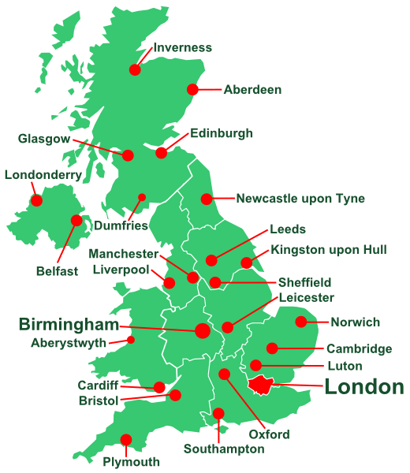
UPLAND REGIONS = SCOTLAND = SPARSE AS FEW NATURAL RESOURCES
LONDON = NATIONAL CAPITAL
LOWLAND AREAS = BIRMINGHAM = EASY TO BUILD ON
*Lots of people live in London and Birmingham and other cities e.g. Leeds. Less live in places e.g. small towns in Scotland

The importance of London as city in the UK and in the wider world:
- It is the UK’s main transport hub
- It is home to the BBC
- There are lots of job available here in government and finance
- Great Ormond Street Hospital is located here
- Lots of companies, both British and foreign, have their headquarters.
- Los of legal work is done here e.g. at the Old Bailey
- Lots of tourists visit the city.

Impacts of national and international migration on the growth and character of the city
- Today, London’s population comes from every part of the world. The largest numbers are from countries like Nigeria and Jamaica (each were once part of the British Empire). Since 2007, more migrants have come from Eastern Europe.

Positives and negatives of migration in London:
To see attractions like St Paul’s cathedral  Lots of different foods  Cultural diversity | Racism  Low paid jobs due to limited speaking of English  Language barriers

Urban change has led to opportunities in London:
Lots of festivals to celebrate cultural diversity and recreational entertainment e.g. Notting Hill
Example of social and cultural + employment = Shoreditch – high tech companies have located on Silicon Roundabout which are high paid jobs. The area has been regenerated and old factories turned into new pubs, there is street art and housing for £330/week
Integrated transport systems improving = Cross Rail is being developed to bring an extra 200 million journeys, less Co2, 1.5 million within a 45min journey and properties along the network will rise by 25%
Urban greening (creating more green space in cities) = 47% of land in London is green space. There are 8.1 million trees, 13,000 species live here, 30,000 allotments and room to exercise in the parks.

Environmental challenges caused by urban growth in London:
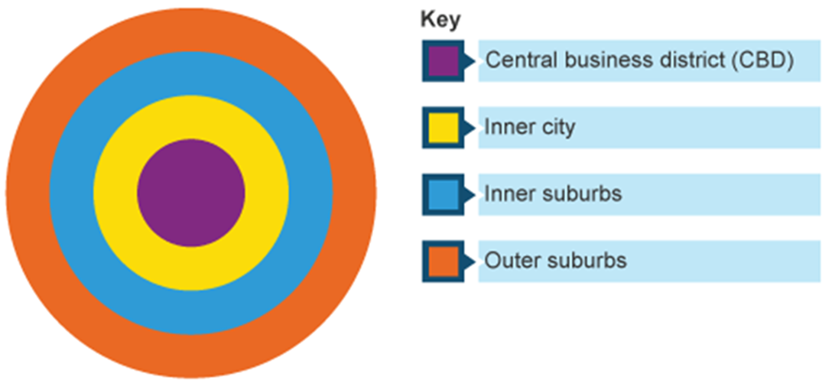
- Despite regeneration urban areas in the inner city e.g. the London Docklands, house prices in London are growing faster than anywhere else. This puts pressure on the RURAL URBAN FRINGE and population pressure too. This = URBAN SPRAWL.
- This puts pressure on wildlife and ecosystems can be damaged/destroyed.
- However, people get better facilities e.g. new shopping centres on the RUF.
- Houses are starting to spread outside of London into areas e.g. Luton. This is creating commuter villages

Challenges in commuter villages:
A commuter village are places in the rural/urban fringe where the majority of the population leaves the town each day to work in the city e.g. Luton to London.

This causes problems:
-New houses change the old character of the towns
-Demand for houses increases house prices for the locals
-Businesses in commuter settlements may suffer as people go back to the city to work.
-Large numbers of commuters can increase pollution

*To cope with the huge amount of urban sprawl in London, there has been a move to building on greenfield and brownfield sites*

GREENFIELD SITES – Never been built upon | BROWNFIELD SITES  -once had buildings on it
Land is cheap to build on as no demolition is needed | It stops dereliction from happening which can lead to crime
Land is more expensive to buy as it has not been built on previously | Existing buildings can be split up to make many houses
Some land is defined as ‘greenbelt’. This land cannot be built upon. This land was established in 1947 and it preserves areas of farmland and woodland | The site has already been developed so reduces urban sprawl
Environmentalists protest about build in greenfield sites as it encourages urban sprawl | More land is available in the North and the Midlands (but houses needed in the South East)
Loss of the countryside | Redevelop the area to make it look more attractive
Could encourage more traffic and pollution | Land could be contaminated as industry was once located there
Easier to access | Land is cheap to buy
Can be more pleasant to live in as they are on the edge of town and cities | Land can be expensive to clear and build upon because of the previous industry left on it
Public transport is worse in rural areas so more need for cars = air pollution | Lots of sites are available due to deindustrialisation
Once the land has been built upon, it is unlikely to ever go back to countryside | Public transport is better in the urban areas so less need for cars
Valuable farm land, habitats or recreation land is lost | Land is more expensive in the urban areas of London
.
Environmental challenges caused by urban growth in London: Waste management
LANDFILL SITES:
24% of London’s waste goes into landfill sites. This might be good because it is out of site, but it produces methane that contributes to greenhouse gases in the atmosphere.
RECYCLING:
61% of London’s waste is recycled into glass, paper and food waste. The government has a target of zero waste going into landfill by 2030.
INCINERATION:
London sometimes burns its waste in order to generate electricity.

Social and economic challenges caused by urban growth in London
Key terms:
Social deprivation = The degree to which a person or a community lacks the things that are essential for a decent life, including work, money housing and services
Poverty = the state of being extremely poor
Life expectancy = The average age that a person is expected to live.
Inequalities = The difference between poverty and wealth as well as peoples 'well being and access to thing like jobs and education

Social and economic challenges in London caused by urban change:
- High urban deprivation e.g. Life expectancy in Knightsbridge is 90, whereas it is 78 in West Ham (this also shows healthcare)
- House prices have increased alongside with greater house shortages (inequalities in housing)
- 37% of residents are not of white British origin which can lead to tensions. This can cause racial issues, language barriers and often when migrants first come to the city, they live in poor quality housing and have low paid jobs (urban deprivation/inequalities in housing)
- Large differences in wealth in the city; Newham (poor – only 7% of people earn more than £60,000 per year) vs Chelsea (where over 26% earn over £60,000 a year (INEQUALITIES in employment )
- Inequalities in education – in Chelsea 82% of children leave with 5 A*-C GCSE’S whereas in Newham only 60% do.
- Inequalities in
- 9,400 deaths a year due to air pollution, mainly nitrous oxide, and 30% increase in the amount of children diagnosed with asthma. This is mainly in people from areas such as Newham (inequalities in health)

An example of an urban regeneration project in London: The 2012 Olympics

WHY WAS IT NEEDED?
- -The Lower Lea Valley needed regeneration because:
- -There was lots of unused industrial land and facilities that had been contaminated by lots of chemicals.
- -Stratford was one of the most deprived areas in London e.g. the average in come is £28,000 per year compared to £38,000 for the rest of London.
- -The River Lea and canals were already there for them to use.
- -To leave a legacy of facilities for the people that live there.

FEATURES OF THE PROJECT:
- *West Ham now play football in the Olympic Park
- *Aquatics centre used for swimming lessons by local primary schools.
- *25,000 employed there in high rise offices.
- *Green space in the Queen Elizabeth Olympic Park for walking
- *Here East Media Centre – 5000 jobs
- *Westfield Shopping Centre – 1000 jobs
- *Stratford Train Station improved for people
- *East Village (where the athletes lived) now has affordable housing for a mix of 2800 homes

OVERALL JUDGEMENT:
- Over 500 people were asked to leave their tower blocks at CLAYS LANE for them to be demolished to make way for the Olympic Stadium led to lots of protests
- Cost £9.3 billion in money
- The cost of living for poor people in Newham/Stratford has increased due to it being a popular area to live.
- Better transport connections e.g. Stratford station
- Newham and Stratford have become very diverse
- The contaminated land has now been cleaned up

Section B: The changing economic world

There are different ways of measuring development according to their economic development and quality of life:
LIC = Low Income Country
HIC = High Income Country
NEE = Newly Emerging Economy

Social and economic measures of development:
Indicator | What it is | A measure of… | As a country develops it gets… | Limitation
Gross National Income (GNI) | The total value of goods and services produced in a country in a year, including income from overseas. In us$. | Wealth | Higher | The figure hides variations between different regions in a country.
Birth rate | The number of live babies born per 1000 of the population per year | Women’s rights | Lower | In LICS not all births and deaths are recorded
Death rate | The number of deaths per 1000 of the population per year. | Health | Lower | In LICS not all births and deaths are recorded
Infant mortality | The number of babies who die per year under 1 years old per 1000 of the population | Health | Lower | In LICS not all deaths are recorded.
People per doctor | The average number of people per doctor | Health | Lower | In LICs a lot of people use their mobile phone to see the doctor so these people are not counted for.
Literacy rate | The % of adults who can read and write | Education | Higher | In poorer countries lots of people live in slums so a lot of people are not asked as they do not have a registered address.
Access to safe water | The % of people who get clean drinking water | Health | Higher | The rising cost of water in poor cities means that some people do not drink safe water even when they can access it.
Life expectancy | The average age a person is expected to live to | Health | Higher | In countries where infant mortality us high, the life expectancy of those who survive childhood is actually far higher than the mean life expectancy.
Human Development Index (HDI) | This is the number that is calculated using life expectancy, education level and income per head. Every country has a HDI value between 0 (least developed) and 1 (most developed) | Combination of health, wealth and education | Higher | The data to make this figure is hard to collect

Limitations of economic and social measures:
Single measures e.g. just using birth rate gives a false impression because:
  - Data could be out of date or hard to collect
  - Data could be unreliable e.g government corruption
Government corruption – unreliable data

It is better to use a multi indicator approach e.g. the HDI
Quality of life:
This means “the wide range of human needs that should be met alongside income growth”. It can be measured by looking at the development indicators above.
Quality of life can be split into 4 categories:
- ECONOMIC – Income, job security and standard of living
- PHYSICAL – diet, climate, water supply
- SOCIAL – family, education and health
- PSYCHOLOGICAL – happiness, security and freedom
The demographic transition model:
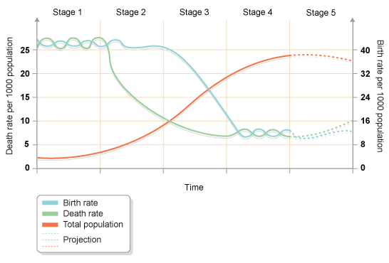
HICs
HICs
NEEs
LICs
LICs

- At stage one the birth rate is high and the death rate is high
- At stage two the birth rate is high and the death rate is rapidly falling e.g Gambia
- At stage three the birth rate is rapidly falling and slowly falling e.g. India
- At stage four the birth rate is low and the death rate is low e.g. UK
- At stage five the birth rate is slowly falling and low and steady e.g. Japan
Reasons for the stages:
- Stage 1 – High birth rate = no use of contraception; High Death rate = poor healthcare, famine
- Stage 2 – Lots of agriculture and children work on the farms which explains high birth rates. Death rates are lower because of better healthcare and diet.
- Stage 3 – Birth rate lower due to women having a more equal place in society and the use of contraception increasing. The death rate falls due to better healthcare.
- Stage 4 and 5 – Birth rate is lower due to people wanting to have children later and the death rate is low as healthcare being good as incomes are high.

Population pyramids (show the population structure of a country at the time in terms of males and females):

HIC E.g. UK
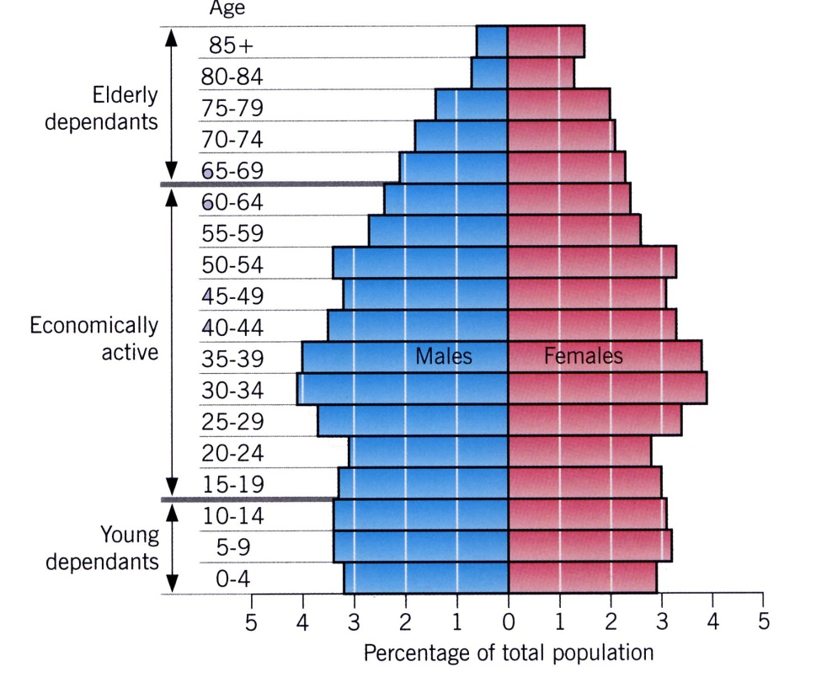
LIC e.g. Kenya
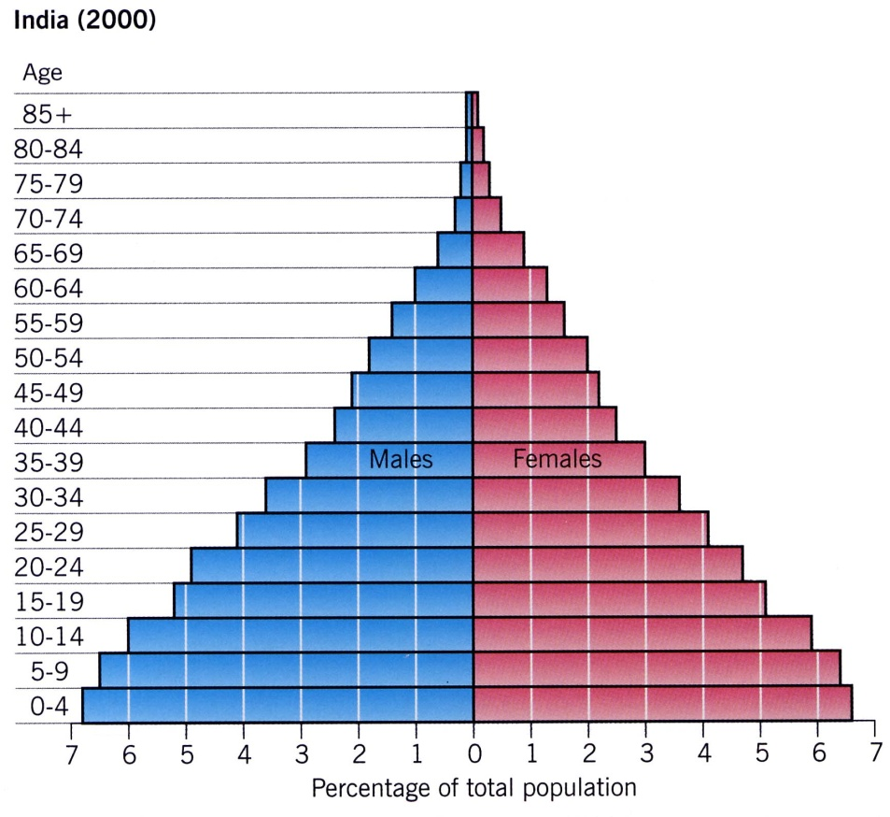

The impacts of overpopulation e.g. in stage 1 and the impact on development:
- Falling incomes High unemployment and low wages (because so many people are wanting jobs that the employers can pay less)
- Environmental degradation Over-grazing of the land and water supplies can lead to soil erosion.
- Reduced health and happiness Malnourishment due to insufficient food and the spread of disease (people’s immune systems weaken when they are hungry).

The causes of uneven development between countries:
HISTORICAL CAUSES:
- In the past colonialism (countries over other countries) led to the slave trade e.g. European countries got lots of resources, such as gold from Africa.
- Even though colonialism ended in the c20th it has meant that some countries are still at a disadvantage e.g. African countries after the countries have become independent. This has led to civil wars which has held back development.
ECONOMIC CAUSES:
- If a country has poor trade links then it will not make money/
- North America and Europe dominate in terms of world trade.
- China and Japan are rapidly emerging so trade tends to take place between the HICS only.
- HICS/TNCs exploit LICS for cheap raw materials and cheap labour.
- NEEs have tried to buy machinery for manufacturing and they borrow money from HICs so this puts them into a ‘debt trap’.
PHYSICAL CAUSES:
- The most landlocked country is Africa. There is no access to the sea for trade.
- Tropical Africa, South America and Asia have lots of climate-related diseases e.g. mosquitoes which cause malaria.
- Poor soils – won’t produce lots of food
- Natural hazards e.g. volcanoes cause injuries to people
- Extreme weather e.g. cyclones, droughts and floods affect Africa and can slow development down by people having to pay to repair things.
- Lack of supplies of safe water.
Uneven development has consequences:
- Differences in wealth:
- LICS become dependent on HICS for aid.
- Many LICS have to borrow money from the World Bank to pay for hospitals and health care e.g. many of the deaths from Ebola were due to Sierra Leone not having good hospital facilities.
- There is a massive difference between rich and poor countries in terms of their Gross National Income e.g. in 2014 North America held 35% of the total global wealth vs Africa with 1%.
- Rich countries can have very poor parts to them and poor countries can have very rich parts to them!

- Differences in health:
- LICS can’t invest in good quality healthcare
- 4 in 10 deaths in LICS are for children under 15 vs only 1 in 100 deaths in HICS.
- In LICS the main causes of death are lung infections, HIV/AIDS, diarrhoea, malaria and TB (these are 1/3 of deaths).
- In HICS the main causes of death area chronic diseases, cancer, dementia and diabetes.

- International migration:
- On a global scale, uneven development leads to unequal flows of people between places.
- Some migrants move for a better life (economic migrants), but some are trying to flee persecution or disasters (refugees).
- 14 million people moved from places like Syria and North Africa due to poverty and conflict.
- In 2015 there were 7 mobile phones for 10 people so even poorer migrants can share information.
- It is not only poor people from LICs crossing borders. The UK receives doctors from Poland.
- Migrants from poor countries send home remittances.

*This increases the development gap = The widening levels in development between the richest and poorest countries*

Various strategies exist to reduce the global development gap:

- INVESTMENT:
Many TNC/HICs invest in LICs to improve their profits e.g. constructing factories in LICs as there will be cheap labour and costs. THIS IS NOT A LOAN! This investment can help poor countries as it can increase employment which will then help the country. For example poverty decreases and education increases. E.g. More than 2000 Chinese companies have invested in Africa.

- INDUSTRIAL DEVELOPMENT:
This is when TNCs invest in industries in LICS. It brings better housing, infrastructure and education. THIS IS CALLED THE MULTIPLIER EFFECT. E.g. in the Proton Car in Malaysia.

An example multiplier effect A factory opens people are employed people paid wages people pay tax government can provide better facilities e.g. healthcare population gets more educated and better off.

- TOURISM:
LICS that have beaches and coasts lead to them becoming tourist destinations. Investors give money from abroad and this can be used for improving the housing, education and infrastructure of a country e.g. the Maldives.

- AID There is different types of aid:
-Short term – emergency help e.g. to a natural disaster
-Bilateral – Aid from one country is given to another (it is tied) e.g. UK sends £338 million to Pakistan a year)
-Multilateral – Richer governments give money to an international organisation e.g. the World Bank then they give it to poor countries
-Long term – Sustainable aid that seeks to improve resilience e.g. reduce droughts.
-Tied – Aid may be given with certain conditions e.g. what the donator wants it to be spent on.
-Voluntary – Money donated via NGOs and Charities e.g. Oxfam has set up a goat project where the goats provide butter, cheese and milk for the local people.

- INTERMEDIATE TECHNOLOGY:
Intermediate technology is sustainable technology that is appropriate to the needs, skills, knowledge and wealth of local people. It must be suitable for the local people. It can involve small-scale projects e.g. water projects that can make a difference to people’s lives. E.g. in Ethiopia they have built a dam to get the water to irrigate people’s fields.

- FAIRTRADE:
Fairtrade ensures that people in poorer countries get a fair deal. It guarantees the farmer a fair price and the farmer gets all the money from the sale of their crop. However, Fairtrade products tend to be expensive.

- DEBT RELIEF:
  - Many of the LICS in the world borrowed money from HICS and this caused a ‘debt crisis’. However, in 2005 the G8 agreed to cancel their debts as long as they could show that they could manage their own finances, there was no corruption in their government and that they could then spend money on healthcare etc.
  - However, some countries may get into further debt as they may expect their debts to be written off and some corrupt governments may keep the money.

- MICROFINANCE:
  - Microfinance is small scale financial support set up to especially help the poor who may not be able to get a bank loan.
  - Small microfinance loans can enable families to set up businesses. Many borrowers are women.
  - As small businesses thrive, employment opportunities increase and incomes rise.
    - E.g. the Grameen Bank in Bangladesh gave women a $200 dollar loan to buy a mobile phone to set up their egg businesses with.
  - The only disadvantage is that people can become reliant on the aid.

An example of how the growth of tourism in a NEE helps to reduce the development gap: Jamaica

Positives of tourism in Jamaica | Negatives of tourism in Jamaica
- 24% of Jamaica’s GDP comes from tourism.  - 20,000 jobs from tourism have meant more money being spent in shops and other businesses. These jobs are better paid  - Government has invested in infrastructure to support tourism – multiplier effect  - New sewage treatment plants have reduced pollution.  - Many local people in key tourist sites of Montego Bay have witnessed improvements in their quality of life.  - The environment has benefited by landscaping and the designation of nature park e.g. Negril Marine National Park has an eco-tourism resort. | - Tourists do not always spend much money outside their resorts.  - Tourism jobs are seasonal  - Infrastructure improvements are focused around tourist resorts and sites.  - Many people in Jamaica still live in poor quality housing and lack basic services such as healthcare whereas Montego Bay is wealthy which causes tensions  - Many of the hotels are owned by foreign companies e.g. TUI and money goes back aboard (economic leakage)  - Lots of damaging effects to the environment e.g. footpath erosion and Co2 from buses and cars

Overall tourism in Jamaica has reduced the development gap by:
In 2015, 2.12 million visited Jamaica for the all-year tropical climate.
In 2014 tourism contributed 24% of Jamaica’s gross domestic product. This is expected to rise to over 30% by 2024.
Tourism income exceeds $2 billion each year.
Tourism is the main source of employment – over 200,000 local people are employed in the sector.

Some LICs and NEEs are experiencing rapid economic development which leads to significant social, environmental and cultural change CASE STUDY = NIGERIA = NEE

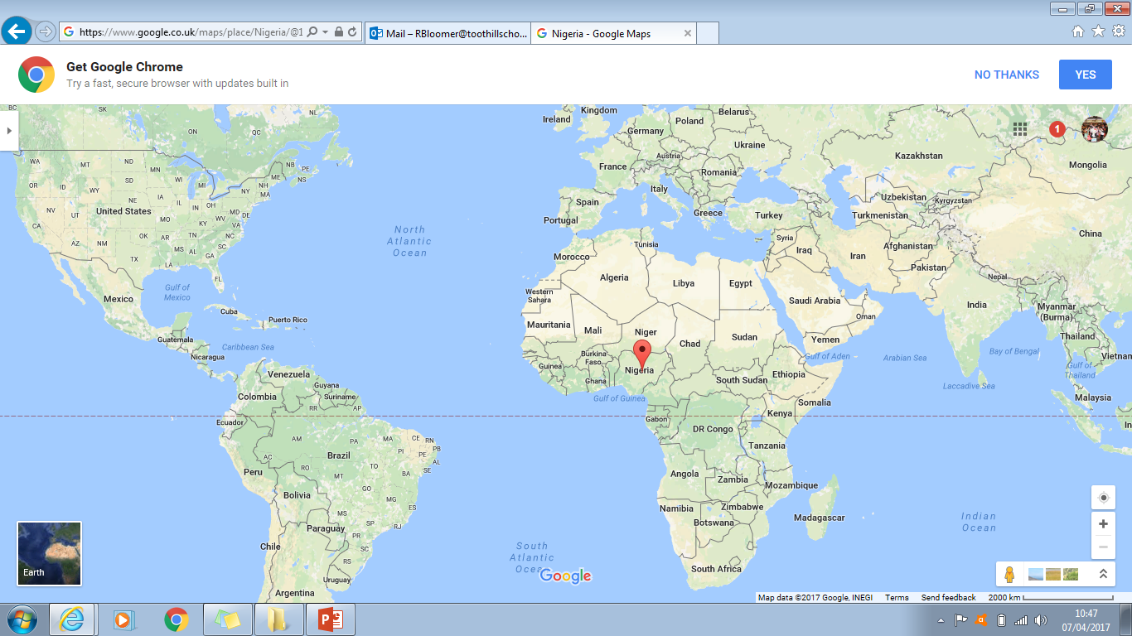
Nigeria is important regionally and globally:
- Nigeria is the world’s 21st largest economy - GLOBAL
- Nigeria supplies 2.7% of the world’s oil (the 12th biggest producer) - GLOBAL
- The economy is an economic hub for finance, telecommunications and the media – GLOBAL
- Nigeria is the 5th largest contributor to the UN peacekeeping missions around the world – GLOBAL
- Nigeria has the highest GDP in Africa – REGIONAL IMPORTANCE
- Nigeria has the third largest manufacturing sector – REGIONAL IMPORTANCE
- Nigeria has 70% of people working in agriculture, mainly subsistence farmers – REGIONAL

The contexts of Nigeria:
- POLITICAL CONTEXT:
- Nigeria became independent from the UK in 1960.
- It is relatively stable. However, there is still conflict in Nigeria. Boko Harm, an extremist organisation, wants to abolish democracy and set up its own government. This conflict has seen 17,000 people be killed since 2002.
- Boko Haram have said to have risen due to the fact that the extremists are able to exploit the growing gap between rich cities and poor rural areas within Nigeria.

- ENVIRONMENTAL CONTEXT:
- The further north of the equator in Nigeria, the climate becomes drier. This means the biome is a savanna grass land.
- The south of Nigeria has tropical rainforests

- SOCIAL CONTEXT:
- There is a mix of religions.
- The average life expectancy is 52.
- The infant mortality rate is 73 babies per 1000.

- CULTURAL CONTEXT:
- Nigerian music is enjoyed across the continent.
- Nigerian cinema, also known as Nollywood, is the second largest film industry in the world
- They have well known writer e.g. Chinua Achebe

Nigeria’s relationships with the wider world:
- IN AFRICA = AFRICAN UNION
This provided troops and allows economic planning and peacekeeping in Africa
- WIDER WORLD = UNITED NATIONS
5th largest number of peacekeeping troops come from Nigeria
- Trades with mainly China, India and the USA

Nigeria’s Industrial structure and economy:
- It was based on agriculture but the economy is now manufacturing and services.
How Nigeria’s manufacturing industry can shape the economy and stimulate economic development:
- Regular paid work gives people more secure income and provides an even larger home market for purchasing products such as cars, clothes and electrical appliances
- Manufacturing industries stimulate economic growth through close links with each other, for example, companies supplying parts for making cars
- As industry grows, more people are employed and the country earns more through people paying tax
- The industrial sector attracts foreign investment which stimulates further economic growth
- Oil processing creates chemical by products. This can lead to a huge range of chemical industries e.g. soap and plastics.
- The standard of living for people increases as they get better products made for them e.g. cement for building over wood
- Producing manufactured goods in your own country lowers imports so good are cheaper for people to buy from Nigeria
- The expansion of Nigerian companies increases Nigeria’s influence on the continent
The role of transnational corporations (TNCs) in relation to industrial development. Advantages and disadvantages of TNC(s) to the host country
Key words:
- TransNational Corporation (TNC): a business that operates in more than one country.
- Multiplier effect: where investment and jobs lead to a knock on effect creating further jobs and services
- Leakage: Money made by a company in a poor country is sent back to the owners in a rich country.

Advantages and disadvantages of TNC’s:
Advantages:
- Local people’s education and skills can be improved by the company
- TNCs can invest in big projects like Dams
- Products are cheaper for people in MEDCs
- Local roads and airports can be improved (infrastructure)
- Money paid to workers in LEDCs goes into the local economy (multiplier effect)
Disadvantages:
- Few of the managers are local people
- Locals are paid low wages
- They can cause air pollution
- Poor working conditions and long hours
- Most profits go abroad (leakage)
- TNCs might pull out with little warning
- There are less laws in poor countries so TNCs can get away with more things
Case study of a TNC: Shell in Nigeria
Advantages of Shell in Nigeria
- 250,000 are employed as a result of the extraction of oil with 65,000 being directly employed by Shell
- 91% of all contracts are with Nigeria which means money stays in the country
- The NNPC has been established which means profits stay in Nigeria
- The government benefits from export taxes, providing money that can be spent on improving education, healthcare and services.
Disadvantages of Shell in Nigeria
- Tankers transport oil to Europe and the USA where it is refined into petroleum products. This means that profits go abroad rather than benefiting the host country. Shell also pays low wages.
- Boko Haram steel 400,000 barrels a day
- 75% of people in the delta have no access to safe drinking water
- The swamp land of Bonga oilfields in dangerous to work on
- 9 million barrels have been split in 5 year This damage the agriculture and water supplies in the area
- Oil fares and toxic fumes have increased air pollution. Oil flares were made illegal in 1984 but they still continue to happen
Aid in Nigeria:
The international aid that Nigeria currently receives:
- Multilateral aid Given by countries through the World Bank.
- Bilateral aid Given directly by another country to Nigeria
- Short term emergency relief Given by charities to cope with immediate disasters e.g. wars
- Long term aid Given by charities to improve health and education etc over the long term
Two aid project examples in Nigeria:
World Bank Aid project in Nigeria (BILATERAL AID):
Nigeria has a high rate of deaths from Malaria (a disease spread by mosquito bites). Therefore, the World Bank and the USA government run a project and have donated 60 million mosquito nets.
The Aduwan Health Centre (VOLUNTARY AID):
The community did not have a health centre and there was high cases of HIV and AIDS. Therefore, Action Aid built a health clinic in 2010. This has enabled lots of people to be tested for HIV aids.

The positive and negative impacts of aid on Nigeria:
In 2014, the World Bank approved $500 million to fund developmental projects and provide long-term loans. This helps to reduce dependence on overseas oil exports.  Aid from the USA helps to educate and protect people against HIV and AIDS  The NGO “Nets for Life” provides education on malaria prevention and distributes mosquito nets to many households. | The government may divert money away for other purposes e.g. claims it has gone to Nigeria’s navy  Corruption by the government and individuals can mean that aid does not get to Nigeria.  Donors may have an influence over where the aid goes and money may be used in the interests of the donor.
The environmental impacts of economic development (industrial growth, urban growth, farming, mining, oil extraction and deforestation) in Nigeria:
Industrial growth | Urban growth | Farming | Mining | Oil extraction | Deforestation
Nigeria has about 5000 registered industrial plants and 10,000 illegal industries.  Some industries dispose of chemical waste onto nearby land and pollute the groundwater.  In Kano, factories pour harmful pollutants directly into open drains and water channels. They are harmful to people and damage ecosystems downstream. | Waste disposal has become a major issue  Services can’t keep pace with the rate of urban growth.  Squatter settlements are common in most cities.  Traffic congestion is a major problem in most Nigerian cities and had led to high levels of exhaust emissions. | Commercial farming has led to land degradation. There is water pollution due to chemicals, soil erosion and the silting of river channels.  Desertification (dry land) is a problem in Nigeria because people are building dams and irrigation schemes. | Tin mining has led to soil erosion. Local water supplies were also polluted with toxic chemicals. | Oil spills can cause acid rain. Some oil developments have led to violent conflicts between local people.  In 2008/2009, Shell spilt 11 million gallons of oil in the Bodo delta. Lots of fishermen lost their livelihoods.  In 2015, Shell had to pay £55 million to the people of Bodo. The money went to build clinics and schools.  Shell has also agreed to clean up the swamping grounds. | Deforestation for building settlements and roads has destroyed many habitats and led to increased co2 emissions.  70-80% of Nigeria’s forests have been destroyed through logging, urban expansion, roads and industrial development  Many species have disappeared due to deforestation e.g. giraffes and 500 species of cheetahs.
The effects of economic development in Nigeria for the quality of life of the population:
- Reliable, better-paid in manufacturing industries or services e.g. health care.  - Higher disposable income to spend on things like school.  - Better access to safe water and sanitation  - Improvements to infrastructure e.g. roads  - Reliable electricity supplies  - Better quality healthcare and better-equipped hospitals.  - Nigeria was rated in 2000 as a least developed nation, but by 2011 it had the highest average HDI improvement in the world. | - Not all people have benefitted and many are still poor.  - There is unequal access to safe water, sanitation and electricity.  - Parts of the North are at risk of desertification and crop failure.  - Boko Haram are kidnapping people and this has put off investment in certain areas.  - There is a large difference between educated and uneducated people.  - 9000 migrants that crossed to Europe in 2014 were from Nigeria as they wanted to escape poverty and earn enough money to send back to their families in Nigeria.

Economic futures in the UK:
Key words:
- Globalisation: the increasing links between different countries throughout the world and the greater interdependence that results from this.
- Interdependence: the relationship between two or more countries, usually in terms of trade.
- Industrialisation: the increase in the amount of manufacturing and decrease in the amount of farming (primary)
- De-industrialisation: the decrease in the amount of manufacturing and an increase in the amount of tertiary (services)
The UK’s economy is split into four different sections:
  - Primary – growing and harvesting natural resources
  - Secondary – making/manufacturing a product
  - Tertiary – services – shops, doctors, lawyers, teachers
  - Quaternary – research – medical
The UK’s economy has changed over time:
- We have moved away from a primary/manufacturing economy and moved towards the tertiary and quaternary sector.
- The tertiary and quaternary sector = A post-industrial economy is where manufacturing industry declines to be replaced by growth in the tertiary sector and quaternary sector.
The development of ICT has meant that we have a post-industrial economy because:
-Store and access lots of data and access it quickly
-The internet allows people to communicate with each other instantly
-Many people can access the internet on their smartphone
-People can work from home using the internet
Lots of people work in finance, research and the service industries.

The causes of economic change in the UK:
Government policy | Deindustrialisation | Globalisation
1945-1979 – The government owned industries in the UK and they spent money keeping them open. This lead to strikes and power cuts.  1979-2010 – The industries were sold off to private companies (privatisation) causing old industries to shut down and high job losses. Privatisation did bring lots of new industries.  2010 – There has been a push in the manufacturing sectors and new policies have included: improving infrastructure (e.g. HS2), loans to small businesses and encouraging global firms to locate in the UK. | Deindustrialisation is the decline in manufacturing industry (manufacturing) and the growth in the service industry.  This has happened because:  -Machines and technology have replaced people  -Other countries like China can produce cheaper goods due to cheaper labour  -Lack of investment and high wages in the UK | Globalisation is the growth and spread of ideas around the world.  It has been made possible due to:  -Developments in technology and communications e.g. the internet  -Cheaper good and services from abroad  -Foreign investment  -Migration  -Less manufacturing  -Inequality  -Outsourcing jobs
A feature of a post-industrial economy = SCIENCE PARKS
*They are big estates where lots of scientific research takes place usually on the outskirts of big cities near to housing and good rail/road links
They help to support new and growing business through research and new ideas
Universities, such as Cambridge works with them and this means they get a good reputation
We demand more products that need to be researched in science parks
E.G. Cambridge Science Park employs over 5000 people, is close to the M11 and close to Stansted Airport
Other features of post-industrial economies:
- Services – retail is the biggest service sector in the UK employing 44 million people
- IT – It is a massive part of the economy with 60,000 employed in it.
- Finance – The UK has global financial quarters e.g. HSBC
- Research – E.g. Science parks.
An example of how a modern industrial development can be made more environmentally sustainable: Quorum Business Park
Before Quorum | Quorum is now sustainable
- 58% of the UK’s chemical and steel industries were there  - Significant air pollution  - Used to be a manufacturing plant  - 5.6% of air pollution comes from there alone. | - Car sharing scheme for workers  - 500 trees planted  - On site litter picking team  - A quorum shuttle bus – Euro 5 engine  - 1000 solar panels  - Lights on sensors  - Glass to let in sunlight  - Two beehives

Social and economic changes in the rural landscape in one area of population growth and one area of population decline
Key term = Counter-urbanisation = This is when large numbers of people move from urban areas into the surrounding countryside/rural areas.
Push factors | Pull factors
Congestion in cities  Pollution in cities  High crime rates in cities  High land values in cities | Less congestion in rural areas  Less pollution in rural areas  Lower crime rates in rural areas  Lower land values in rural areas

An example of an area where there has been population growth in a rural area = SOUTH CAMBRIDGESHIRE:
- Commuters continue to use services in places where they work, for example, Cambridge – this has a negative effect on the local-rural economy.
- 80% car ownership is leading to increased traffic on narrow country roads and reducing the demand for public transport.
- Modern developments on the edges of villages and gentrification of abandoned farm buildings can lead to a breakdown in community spirit.
- Young people can’t afford the high cost of houses and move away.
- A reduction in agricultural jobs as farmers sell their land for housing developments.
- Lack of affordable housing.
- This area has some of the highest petrol prices in the country due to high demand.
- The increasing number of migrants from poor parts of Europe can put pressure on services and increase costs.
An example where there has been population decline in a rural area = THE OUTER HEBRIDES:
- The number of school children is expected to fall over the next few years and this may result in school closures.
- With many people moving away there will be fewer people of working age living in the Outer Hebrides.
- An increasingly ageing population with fewer young people to support them may lead to care issues in the future.
- The main farming economy is breeding sheep on small farms called crofts.
- Most crofts can only provide work for up to two days per week.
- The development of fish farming has been limited due to concerns about the environment.
- In 1948, there were more the 900 fishing boats in the Outer Hebrides. By 2013, there were just a few boats catching lobsters and prawns.
- Between 2007 and 2014, there was a 27% increase in visitors to islands.
- The current infrastructure is unable to support the scale of tourism needed to provide an alternative source of income.

Improvements and new developments in road, rail, airports and ports
ROAD = There will be 100 new roads by 2020 to ease congestion and ‘smart motorways’
RAIL = A new Crossrail will be build connecting Heathrow and Reading to West London at a cost of £14.8 billion.
PORTS = A new port is being built at Liverpool called Liverpool2. The cost is around £300 million and it going to double capacity to over 1.5 million containers a year so the economy of the north-west will be boosted and compete with other UK ports.
AIRPORT = Heathrow could expand by 2030 at a cost of £18.6 billion.
Example of an improvement in rail infrastructure (also something that reduces the N/S divide) = HS2 | Example of an improvement in airport infrastructure = the proposed Third Runway at Heathrow
POSITIVES:  -Rising travellers – need it to cope with 2x demand.  -Boost the economy £7billion extra a year  -New planes e.g. Airbus A380 – not polluting  -10,000+ jobs | POSITIVES:  -Rising travellers – need it to cope with 2x demand.  -Boost the economy £7billion extra a year  -New planes e.g. Airbus A380 – not polluting  -10,000+ jobs  NEGATIVES:  -Heathrow generated 6% of the Uk’s co2 emissions.  -Exceed EU regulations on nitrous oxide.  -200,000 extra flights asthma and high blood pressure  -Sipson – 700 houses knocked down.

The north-south divide:
“The North South Divide is often referred to as the cultural and economic differences between Southern England and Northern England”
Arguments for and against the North/South Divide:
FOR
Education:
- OFSTED stated that there is a north south divide. The north has a lower % of good and outstanding schools
- On average, 70% of pupils attain 5A*-C in London. In Yorkshire, this number is 63%
- 13 out of 16 schools where less than 60% of pupils in the area attend a good or outstanding school are in the north
Pay:
- London and the South East are the only two places in England with wages above the national average
- North East has the worst pay in the UK
- Average wage in the North East = £17,000 and in London = £35,000
Flood Defences:
- Government have been criticised for spending more money on flood defences in the south - £122 per person in the North and £167 per person in the South.
- North East worst hit by flood in 2016 and only has £30 per person spent on flood defences.
- Leeds barrier £180million (North) was cancelled and replaced by a smaller, £45millon barrier
Money:
- Loss of industry e.g. mining and steel in the north = loss of money in the area and unemployment
- Slow economy growth in the North whereas the South is growing (prosperous)
- Average savings = £9,000 in South
- Average savings = £7,000 in North
Housing:
- Average home is £150,000 more in the South (3.5 times higher overall price)
- Gap of housing continually widening.
- Average home in London = £514,000 Average home in North = £154,000
Strategies used in an attempt to resolve regional differences (NORTH SOUTH DIVIDE):
- The Northern Powerhouse Building things in the North to boost growth and balance the wealth e.g. the HS2 and upgrading the M62.
- Enterprise Zones The government support businesses by improving a discount of up to £275,000 over a 5 year period and have superfast broadband and low taxes.
- Local enterprise partnerships They are run between local authorities and businesses. They aim to get businesses to come into the area.
- Assisted area The government give a loan for a business/ industry to be located in an area.
- The HS2 (see above)

The place of the UK in the wider world. Links through trade, culture, transport, and electronic communication. Economic and political links: the European Union (EU) and Commonwealth.
- TRADE: The UK trades with the USA, Europe and Asia. It exports £350 billion each year.
- ELECTRONIC COMMUNICATIONS: The internet allows the UK to trade e.g. 1 in 6 people run a business from home using the internet.
- CULTURE: UK culture has spread in the commonwealth. A lot of other countries are modelled on the UK e.g. the BBC exports the news abroad.
- TRANSPORT: The UK transports goods via ferry and rail e.g. across the channel tunnel.
- COMMONWEALTH: The UK has links with 53 countries

The EU impacts on the UK by:
- There are EU laws and controls on crime, pollution and consumer rights.
- The UK may have to support poorer member countries by paying more money to the EU.
- High unemployment and low wages in poorer EU countries particularly in Eastern Europe. This may lead to mass migration of workers to the UK.
- The EU provides financial support for farmers. The single payments scheme was introduced in 2015 and is part of the EU’s Common Agricultural Policy. In 2015, £18 million was made available to support dairy farmers in England and Wales.
Section C: The challenge of resource management
Here you need to know a little bit about food and water. You then need to answer section 6 about ENERGY.

Key words:
Resources | Stock or supply of something that has a value or purpose
Undernutrition | Having access to less than 2000-2400 calories per day
Malnourished | A poorly-balanced diet lacking in minerals and vitamins
Scarcity | When a resource is short supply
Insecurity | A resource which will run out at short notice or may not always be there
Supply | Meeting a demand
Consumption | Using a resource

The supply and consumption of resources is uneven:
- The supply of resources is uneven. Some countries do not have very good climates to grow things.
- To get resources, some countries have to import them and this is expensive
- The consumption of goods is higher in HIC as people can afford to buy resources
- The consumption of goods is lower in LIC as they can’t afford to exploit the resources or import the resources.
- People’s social and economic well-being is reduced in LICS when people have to go to find water, catch diseases via drinking dirty water and being malnourished.

The UK:
- Food:
Food miles = The distance food travels from the farmer to your dinner plate.
The UK demands lots of food to be imported and has lots of food miles because:
- Supermarkets import cheaper products to sell at competitive low prices.
- Demand for greater choice and more exotic foods
- UK climate is unsuitable for growing certain food e.g. cocoa
- Demand for seasonal food all year round e.g. strawberries
The impacts of the demand for food/importing food:
We require fruit and vegetables to eat all year around e.g. mangoes which can’t be grown in the UK due to the climate.  Jobs are created for Kenyan people, such as in farming packaging and transport.  People can get luxury products in the UK e.g. Madagascan vanilla.  The government are then paid taxes from people’s wages which can then fund facilities for the country, such as schools and hospitals. | The farmers lose out on money as the companies in the UK sell the food for often 5x the price it cost to sell.  The crops require high amounts of water to grow which is a problem as often there is a lack of water.  Sometimes the people growing the crops are exposed to chemicals, such as pesticides without protective clothing.  There are food shortages in some countries, such as Kenya as the land that farmers used to grow food on for their families is now used to grow food for companies in the UK.

The demand for food in the UK is leading to two strategies to get more food
- Agribusiness
- Organic food

Organic Food: Produces food naturally without spraying on any fertilisers and pesticides. Grown without using lots of machinery. | Agribusiness: Uses lots of chemicals and pesticides to grow a lot of food very quickly. Uses lots of machinery to help things grow quickly.
- Grown and sold locally  - Reduced food miles  - Supports local farmers  - Provides local employment  - Seen as a healthier food option as it does not use chemicals such as pesticides.  - The food grown is often seasonal so some food would still need to be imported  - Higher labour costs (need more workers)  - Expensive to grow and sold at a higher price  Example: Riverford Organic Farms which produces veg and dairy boxes for people on a weekly basis in Devon | - More food can be grown in the UK  - Less reliant on importing food from other countries  - More money spent on food in the UK – improving the economy  - Pesticides are harmful to the environment and can kill bees  - The land can become infertile if it is over used.  - Modern technology has meant a loss in jobs available.  Example: Lynford Hurst Farm which is 570 hectares and grows lots of potatoes. It uses lots of water from the local reservoir to grow the crops.

2)Water:
Key words:
Water surplus: where water exceeds demand (often in the North)
Water deficit: where demand exceeds supply.
Water stress: where demand exceeds supply for more than half of the country (often in the South)
Population density: number of people living in a km²

A strategy to maintain water supplies = water transfer
What is it?
Water transfer is simply the movement of water.
How will it work?
In 2006, the government designed a water grid plan to transfer water from areas of water surplus (extra) to areas of water deficit (not enough) – it was not approved!

- Would deal with UK water stress  - Help to grow crops  - Use water appropriately without wasting it. | - Expensive  - Destroys habitats and wildlife  - Lots of co2 released in pumping water over large distances

Water pollution (causes impacts and management):

CAUSES | IMPACTS | MANAGEMENT
Chemicals such as pesticides and fertilisers run off from farming land  Untreated waste from factories  Pollution e.g. oils from boats often end up in rivers and coastal waters | Fertilisers can increase the speeding up the growth of algae which can decrease oxygen supply in the water so wildlife can die.  Bacteria in sewage water can spread diseases  Pesticides can kill certain animals in the ecosystem which can lead to food chains being disrupted | Things like roads are built close to rivers to act as water traps to catch pollution before it enters the river  Waste water treatments remove things like bacteria from the water and produce clean water for human consumption  In cities, some buildings have green roofs and walls which filter out rainwater and pollutants. They can also absorb carbon dioxide for the atmosphere.

- Energy:

The UK’s energy mix has changed:
- The UK used to rely on coal oil and gas from the North Sea.
- In the 1990’s nuclear energy became popular
- Since 2014 there has been a big shift towards using renewable resources e.g. wind, biomass and HEP.
- We are moving towards more renewable energy sources because our supplies (domestic supplies) in the North Sea are running out, we have used 75% of our non-renewable reserves and it is better for the environment to use renewables.
- The last coal mine shut in 2015
- The UK is currently using a mix of non-renewable and renewable reserves.
Economic and Environmental issues associated with the exploitation of energy sources:
ECONOMIC  -Extracting fossil fuels = expensive  -If the price of oil drops then it would cost more to produce than to be sold for.  -Producing electricity from nuclear = expensive  -Renewable energy does not produce a reliable amount of energy. | ENVIRONMENTAL:  -Fossil fuel burning = c02 increase  -Fracking pollutes groundwater  -Accidents can happen e.g. oil spills  -Natural ecosystems may be damaged by renewable energy  -Power stations and wind farms = Eyesores

Nuclear (non-renewable)  Expensive to produce electricity  Radioactive waste is hard to get rid of and expensive  Waste water can damage ecosystems  Good alternative to coal and gas  Provides jobs  Lots of energy generated | Wind (renewable)  Doesn’t work if not windy = expensive  Eyesores  Birds can fly into turbines and die  No c02 released  Tourist attractions – boost the economy  Renewable – won’t run out

Section 6 = ENERGY

The world is increasing in energy consumption because:
- Economic development e.g. more businesses
- Rising development e.g. cars, fridges, tv’s
- Rising population e.g. 9 billion people in the world by 2040
- More technology e.g. mobile phones require energy to charge
Energy consumption is….
- High in the USA, Canada, Australia and Europe.
- Low in Africa and parts of South East Asia.
Countries that have a lot of energy are…
- Saudi Arabia and India = Lots of oil
Countries that do not have a lot of energy are…
- Sudan due to lack of money and Ireland does not have many resources

The factors that effect energy supply (the amount of energy):
Cost of exploitation and production
- Some energy resources are hard to exploit e.g. oil rigs.
- Nuclear power stations are hard to build

Presence of geothermal technology (PHYSICAL FACTOR):
Geothermal energy is produced in areas of tectonic activity, such as Iceland and the Pacific Rim. Therefore we can only create it a country lies on plate margins

Geology of an area (PHYSICAL FACTOR):
We can only mine and get fuel in areas where gas, oil and shale gas are found in rocks!

Climate (PHYSICAL FACTOR):
- The amount of sunshine and wind influence the availability or solar energy and wind energy. No sun = no energy so the UK receives less sun in winter so we create less solar energy in winter
- Tidal energy needs a large tidal range in order to be effective so can only be created near the sea
- Hydro Electric Power (HEP) needs a suitable dam site, often in sparsely populated mountainous areas with high rainfall.

Technology:
- Technological advances have allowed energy sources in remote or difficult environments, such as the North Sea and the Arctic, to be exploited. Better, improved technology = more energy

Political Factors:
- Political instability (corrupt governments) in the Middle East e.g. Iraq has meant that many oil-consuming countries (e.g. USA/UK) are looking for alternative sources of energy as they do not want to give money to corrupt governments.
- Some agreements e.g. climate change agreements such as the Kyoto Protocol means that some countries now do not want to burn fossil fuels.

The impacts of energy insecurity:
- The balance between energy supply (production) and demand (consumption) = the level of energy security.
- If supply is bigger than the demand for it then the country has an ENERGY SURPLUS e.g. the Middle East
- If the supply is less than the demand for it then the country has an ENERGY DEFICIT AND THE COUNTRY HAS ENERGY INSECURITY! E.g. Western Europe

An example of a conflict caused by energy insecurity:
1.The EU gets its gas supplies from the Ukraine – 80% of this passes through Russia.
2.Russia and the Ukraine regularly fall out over the price of gas and how much it would cost the Ukraine for the gas to pass through Russia.
3. When they last fell out in 2008 it meant that the gas supply to Europe was cut off
4. This meant that schools, businesses and industry had close. People had to use fires for warmth.

The social, economic, environmental and political impacts of energy insecurity:
SOCIAL  Energy insecurity leads to jobs being put at risk as the sales of goods and services may fall.  In low income countries, energy insecurity means that people (often women) have to spend hours walking to collect wood  Modern farming requires lots of energy to power machines and therefore when there is little energy the prices of energy go up. This then means that the farmer has less money. | ECONOMIC  Farmers in countries where there energy insecurity have to put the prices of their food up in order to be able to compete with poorer countries.  Energy insecurity can lead to people at home having to pay more money for their bills.  Energy insecurity leads to an increase in the cost of living e.g. more to run the home, make food and travel. | ENVIRONMENTAL  People clear areas of the rainforest for wood and then use the land to grow biofuels e.g. in the Amazon Rainforest.  People have to build wind and solar panels in areas of scenic beauty.  People flood valleys e.g. the Three Gorges Dam in China for Hydro-electric Power and this means that people have to move house. | POLITICAL  Energy insecurity may lead to conflict between different countries e.g. Russia and Ulkraine.  Energy insecurity can mean that people at home get an unreliable source of energy e.g. having power cuts. This happens in Pakistan where regular power cuts can last 20 hours.  In areas of energy insecurity, the likelihood of terrorism or hijacking of oil trucks is high.

The main impacts of energy insecurity:
- Economic and environmental costs When a country has fuel they will make their prices higher. The use of coal has caused problems of smog in places, such as China.
- Food production Growing bio-fuels can take up lots of farmland which can reduce the amount of food that can be grown and cause prices to rise. If energy is in short supply then it costs more to produce and transport goods.
- Industrial outputs If energy is in short supply then manufacturing becomes expensive.
- The potential for a conflict where demand exceeds supply e.g. Ulkraine
- The exploration of difficult and environmentally sensitive areas (see Arctic case study)

The exploitation of the Arctic:
In the past resources e.g. coal was easy to find but now it is being used up in places such as the North Sea, it means that unexploited places, such as Antarctica are being used.
of using the Arctic  It holds 90 billion barrels of undiscovered oil  It holds 30% of the world’s undiscovered natural gas  It could supply the world’s energy in the future,  The extraction of oil/gas is difficult and expensive as you need special machinery to withstand cold temperatures. | of using the Arctic  If there was an oil spill then it would ruin the Arctic ecosystem as it would take ages to recover due to the low temperatures.  People demand high wages to work there  Political issues may arise because 8 countries have territorial claims there

Different strategies can be used to increase energy supply:
RENEWABLE  - A resource that cannot be exhausted – they are infinite  - Renewable energy is SUSTAINABLE  Biomass  Wind  Hydro-electric power  Tidal  Wave  Geothermal  Solar | NON-RENEWABLE  - A resource that can be exhausted and cannot be replaced within human timescales – they are finite  - Non renewable energy is UNSUSTAINABLE  Coal  Oil  Gas  Nuclear
The options:
OPTION | WHAT IS IT
COAL (NR) | Fuel formed from plants that were buried years ago | - Can be easily transported to power stations  - Relatively cheap  - Some places still have coal | Burning it releases o2  Coal miners can get black lung disease  It will run out in the next 100 years
NATURAL GAS (NR) | Fuel formed from the pressure of plants and animals buried years ago | - It is not dependent on the weather  - Natural gas can be found in lots of places around the world  - We can transport gas in pipes by using tankers or ships | UK North Sea gas reserves are declining so the UK has to rely more on importing it.  The price of gas is very changeable and can rise and fall sharply in response to international events outside the UK’s control.  Burning gas releases greenhouse gases.
OIL NR | Fuel formed from the pressure of plants and animals buried years ago | - Oil is found in lots of places in the world  - We can transport oil in pipes and by using tankers and ships | - Environmental damage can be caused when building the rig and by accidental oil spillages  - Oil is not renewable and will run out.  - Burning it releases greenhouse gases. This may add to global warming.
NUCLEAR NR | Using radioactive materials (e.g. uranium) to create heat which turns water into steam to turn a turbine to generate electricity | Does not make harmful greenhouse gases  You only need a small amount of nuclear fuel to make energy | Non-renewable will run out in the next 50 years  Nuclear power stations are very expensive to build  Radioactive waste
WIND R | Made by the wind turning the blades of turbines to create electricity. | Wind is free  Will not run out  No c02 | It costs a lot and can be difficult to set up  The energy cannot be stored (so no power if it’s not windy!)  If it’s too windy, turbines can be switched off as they are at risk of breaking.  They may harm birds if they fly into them.
WAVE R | The waves spin a turbine | Waves are free  Waves won’t run out  Does not produce c02 | Wave energy generators may be a hazard to ships  They can be noisy  Waves can be small so can’t generate electricity
TIDAL R | Using the movement of sea water, underwater turbines generate electricity. | Free power  No CO2  Know when tides happen so can make electricity | Can interfere with ships and wildlife (imagine if you were a bird, fish or seal faced with that!)  Not very efficient (only 2% of the tides energy is converted to power)  Not as useful for inland areas (away from the coast)  Costs a lot to set up
GEOTHERMAL R | Cold water is pumped to deep beneath the earth’s surface to be heated in a tectonic area | - No Co2  - Free  - Won’t run out | Limited to tectonically active countries  Harmful gas and minerals may come up from the ground below = difficult to destroy
SOLAR R | Using the sun to generate electricity using solar panels | Once set up, running costs are very low  Governments offer schemes if you have solar panels on your house where you can earn money if you generate more than your household uses.  Great potential in some LICs with a lot of sunshine. | Energy production is seasonal  Solar panel ‘farms’ need a lot of space  No energy at night
HEP R | Water produces electricity via a dam and reservoir | Once construction is complete, operating costs are very low  No waste or pollution is produced  Electricity can be generate constantly, because water can be stored and used as needed | People have to move to build the dam  The dam is expensive to build  The area may flood habitats
BIOMASS R | Growing plants in a managed way (e.g. trees, sugar beat) which can be burnt to generate electricity and heat. Plants can also be grown to create biofuel to be used in vehicles. | - Fuel is cheap  - Burns items that we would otherwise put into landfill  - Waste will never run out | - Burning organic matter can create smokey unhealthy conditions  - CO2 released  - May not have enough space for the fuel

The advantages and disadvantages of extracting a fossil fuel: FRACKING (the extracting of natural gas by drilling into rocks which contain shale gas).
of fracking  It is the cleanest of the fossil fuels with less than 45% less CO2 emissions  Less risk of accidental accidents than oil.  Provides employment for 1.2 million people. | of fracking  Wastewater and chemicals could contaminate groundwater and minor earthquakes are possible.  Contributes to global warming by producing C02 emissions and methane.  Pipelines are expensive to build and maintain.

An example of the advantages and disadvantages of extracting a fossil fuel: Camisea project in Peru, (Amazon rainforest)
Save Peru $4 billion in energy costs.  Peru could make $34 billion in gas exports.  It provides employment and helps boost the local economy.  Infrastructure would be improved which makes agriculture more productive. | Deforestation associated with the pipeline and other developments will affect natural habitats.  The project could impact on the lives of indigenous tribes and their traditional way of collecting food.  Native tribe more likely to catch diseases as they have no protection  Clearing routes for pipelines has led to landslides and pollution of streams resulting in the decline of fish

Moving towards a sustainable resource future…
Key terms:
- Energy conservation – reducing energy consumption by using less energy and existing source more efficiently
- Carbon footprint – measurement of greenhouse gases individual’s produce, through burning fossil fuels
Being sustainable can be done at a number of scales:
PEOPLE = INDIVIDUAL SCALE
TRANSPORT = NATIONAL SCALE
HOMES AND OFFICES = NATIONAL SCALE
CITIES = NATIONAL SCALE
At an individual scale people can be sustainable by:
- Financial incentives People are offered money by companies for doing things such as switching to paperless bills
- Raising the awareness of being environmentally friendly e.g. walking, turning lights off.
- Using off peak energy tariffs Energy is cheaper to use energy at off peak times.
- Using less hot water for domestic appliances Ariel had a campaign to wash at 30 degrees.

At a national scale people can be sustainable by:
- South facing homes.
- Using renewables e.g. wind power
- Cavity wall and loft insulation
- A rated energy appliances
- Energy efficient lights
- Double glazing
- Building on brownfield sites

An example of a local scale renewable energy scheme in a LIC: SOMPURA IN INDIA
*Makes energy via burning cow manure = BIOMASS = Energy for 4000 locals*
Advantages of the scheme
- Women and children have gained 2 hours a day. Women can now go to work an children can go to school and get an education
- The excess dung, the slurry, is used to fertilise the crops
- The 240 cows are kept in compounds so the dung is easy to collect
- The 430 residents have enough biogas created for cooking with surplus for lighting and pumping drinking water
- It has created light for children to do homework with
- The lights are used for cooking which has made it less dangerous
- Cost effective
Disadvantages of the schemes
- The gas can often run out before the second meal of the day which means it is not warm
- If there is a shortage of money to buy food for the cattle, less dung is created
- If there is an natural disaster, in particular droughts, the cows do not create as much dung
- Some specialist equipment had to be imported which is expensive

