 | Paper 3
Date: | 11th June 2020
Length: | 1 hour 15 minutes
Time of day: | AM
Total number of marks: | 76  6 marks for SPaG
Equipment needed: | 2 black or blue pens  2 pencils  Ruler  Calculator
Topics covered: | Section A – Question 1: Issue Evaluation – 37 marks – answer all questions  Section B – Question 2: Geographical skills and fieldwork – 39 marks – answer all questions  Question types: multiple-choice, short answers, 2 x 9 markers.

Section B: Geographical Skills and Fieldwork
You need to be aware of the different skills. They could appear in any topic.
Cartographic skills (Maps)
Latitude – these are lines that go horizontally across the world. There are three major ones – Tropic of Cancer, Equator and Tropic of Capricorn. You should refer to these if on a map in distribution type questions.
Longitude – these are the lines that go vertically (top to bottom) on our Earth.
You read these like co-ordinates or grid references.
Population density/Rainfall density maps
Population density refers to the amount of people living in one area. Use the key to establish the pattern and quote data and compass directions
Rainfall density shows the amount of rain in an area. Use the key to establish the pattern and quote data and compass directions

Describing distribution
When describing distribution make sure you do the following:
- Refer to the lines of latitude
- Use compass directions
- Combine compass directions and the position of the feature on the continents
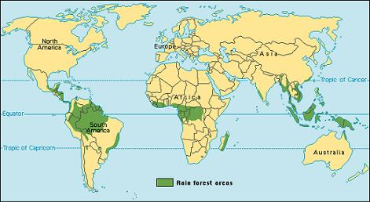
For example:
Tropical rainforest is found between the tropic of cancer and tropic of Capricorn. It is also found on the equator. The largest expanse is found in the north-east part of South America spreading to the west. In Africa the rainforest tis found on the west coast and spreads in towards the centre of the Africa.

Topological maps
These maps see the features of geographical phenomenon but do not often have a scale. Symbols and colours are used to show patterns
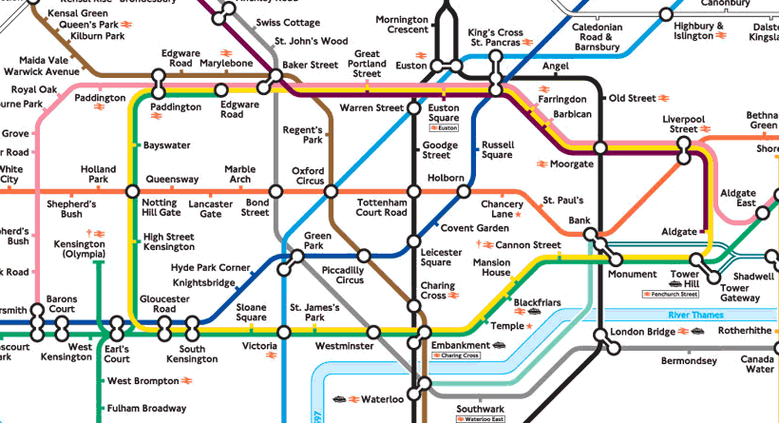
OS Maps
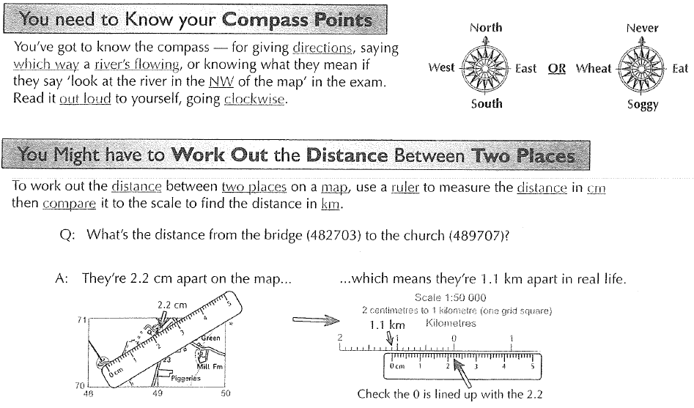
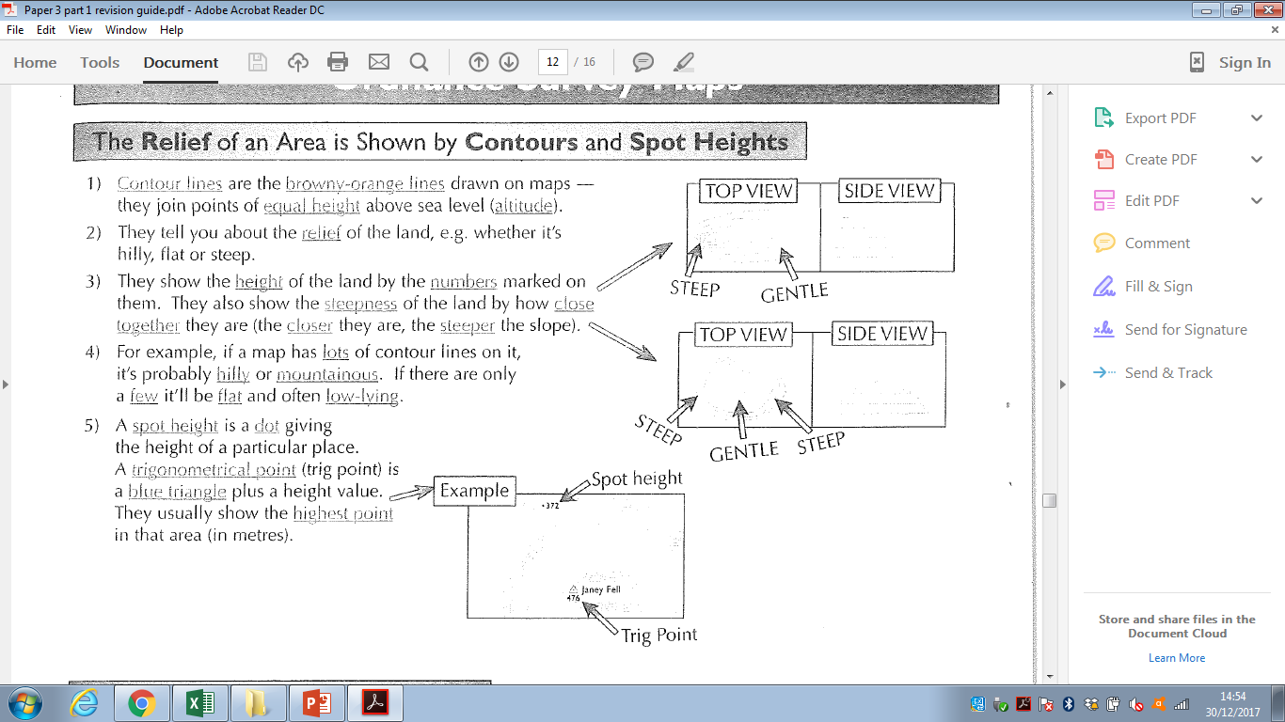
Maps in association with photographs
Labelling:
You might have to label photos, diagrams or maps:
- Figure out from the question what the labels should do, e.g. describe the effects of an earthquake, label the characteristics of a waterfall, describe the coastal defences.
- Add at least as many labels as there are marks
- When describing feature about things like the size, shape and relief. Make sure you use the correct geographical names of any features, e.g. wave-cut platform, meander

You will have to label and annotate difference features.
Label – make a statement/identify a feature
Annotate – explain with a label
Make sure your arrows touch the feature you are labelling or annotating.
Comparing photographs and plans
You might be given two items, like a plan and an aerial photograph, and be asked to use them together to answer some questions. Plans and aerial are a bit like maps – they show places from above.
- The plan and photo might not be the same way up
- Work out how the matches the plan – look for the main features of the plan like a lake, a big road or something with an interesting shape and find them on the photo.
Look at what’s different between the plan and the photo and think about why it might be different

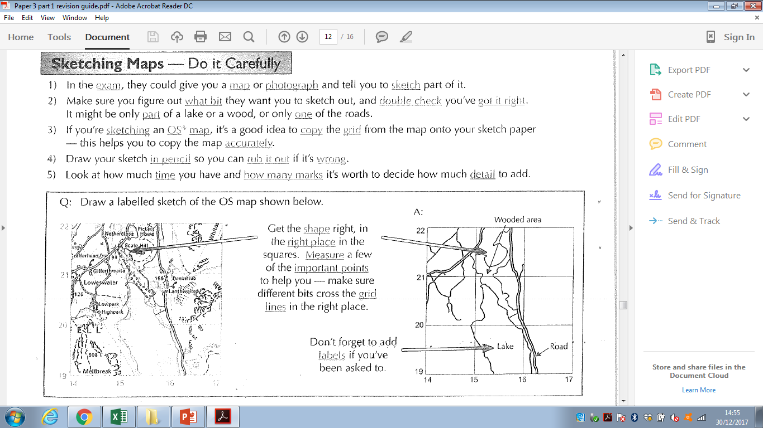

Satellite, ground and aerial photographs
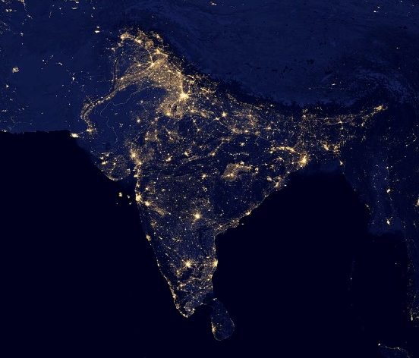
You treat these exactly the same as each other. You say what you can see. Talk about different features in relation to each other. Use a scale to give distance if given one.

Graphical skills
Dealing with graphs
You might have to do the following:
- Complete the graph - add in a column, fill in a pie chart segment etc.
- Describe the pattern or trend:
  - Identify the trend is it increasing, decreasing or fluctuating – is this rapid, slow
- Use data and years in your answer
- Do a small sum to say by how much it has increased by
Line graphs – the points are joined by lines
To read a line graph:
- Read along the correct scale to find the value you want
- Read across or up to the line you want, then read the value off the other scale
To complete a line graph:
- Find the value you want on both sides
- Make a mark (e.g. x) at the point where the two values meet on the graph
- Using a ruler join the mark you’ve made to the line that it should be connected to
Bar charts – draw the bar straight and neat
- Read along the bottom to find the bar you want.
- To find out the value of a bar in a normal bar chart – go down the top of the bar across to the scale and read off the number.
- To find out the value of part of the bar in a divided bar chart – find the number at the top of the part of the bar you’re interest in, and take away the number at the bottom of it

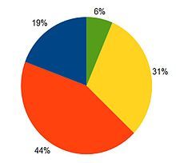
Pie charts
- You might need to complete a pie chart. You should be given the information in % already.
- The pie chart template will have sections drawn in already.
- Carefully look at the pie chart – is the template split into 5% or 10%
- Draw the pie chart carefully – using the same shading as the key given

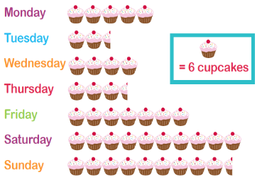
Pictograms
- You use an image to show the amount of the data
- Look at the scale and key given – think about half sizes
- Draw the appropriate image
- This is often in a column format

Histograms are a lot like bar charts
- Histograms are very similar to bar charts, but they have a continuous scale of numbers on the bottom and there can’t be any gaps between the bars.
- You can use histograms when you data can be divided into intervals.
- You draw and plot them just like a bar chart, but you have to make sure that the bars are the correct width, as well as the correct height

Scatter graphs show relationships
Scatter graphs tell you how closely related two things are, e.g. altitude and air temperature. The fancy word for this is correlation. Strong correlation means the two things are closely related to each other. Weak correlation means they’re not very closely related. The line of best fit is a line that goes roughly the middle of the scatter of points and tells about what type of correlation there is.
Data can show three types of correlation:
- Positive – as one thing increases the other increases
- Negative – as one thing increases the other decreases
- None – there’s no relationship between the two things

Reading scatter graphs
- If you’re asked to describe the relationship, look at the slope of the graph, e.g. if the line’s moving upwards to the right it’s a positive correlation. You also need to look at how close the points are to the line of best fit – the closer they are the stronger the correlation.
- If you’re asked to read off a specific point, just follow the rules for the line graph (top right of the page).
Completing scatter graphs
- You could be asked to draw a line of best fit – just draw it roughly through the middle the scatter of points (equal numbers of points on each side)
- If you’re asked to add a point – follow the line graph rules
- You can use your line of best fit to make predictions by reading off values from the graph.
- If you’re confident your best fit line will continue, you can extend it beyond the data you have collected. This means you can make predictions outside the range of data you collected.
Interpolate data – you might be asked to read from the middle of the line of best fit. Use the different axis and read like a line graph.
Extrapolate data – you might be asked predict what it might be like in the future – extend the line of best fit and read the different axis and read like a line graph

Population pyramids show the structure of a population
- Population pyramids are a bit like two bar charts on their sides
- It’s a way of showing the population of a country by age and gender
- The number of people goes on the horizontal axis, and the age groups go to the vertical axis. The left side is the male population and the right side is the female population

Different types of maps and data
Choropleth maps show how something varies between different areas
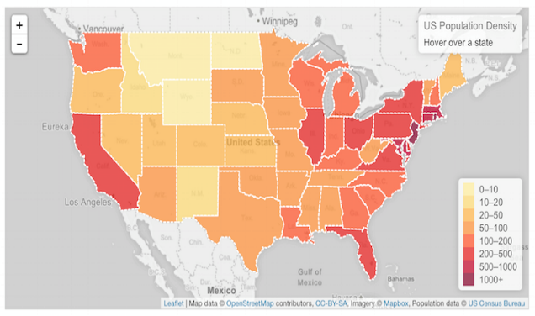
- Choropleth maps show how something varies between different areas using colours or patterns
- The maps in exams often use cross-hatched lines and dot patterns
- If you’re asked to talk about all the parts of the map with a certain value or characteristic, look at the map carefully and put a big tick on all the parts with the pattern that matches what you’re looking for. This makes them all stand out
- When you’re asked to complete part of a map, first use the key to work out what type of pattern you need. Then carefully draw on the pattern, e.g. using a ruler

Isoline maps
- Isolines are lines drawn to link different places that share a common value. The prefix 'iso' is a greek word meaning equal, so an isoline must be a line joining equal points.
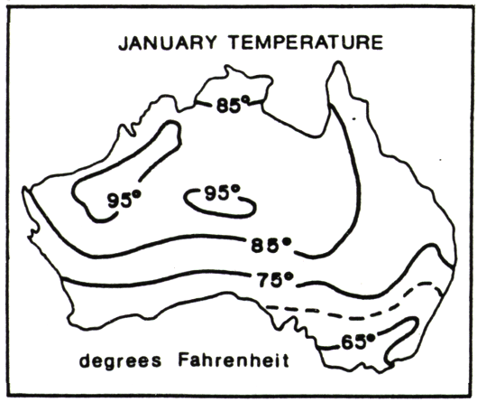
- For example, a line drawn on a map to join up all the places that are the same height above sea level is called a contour. Contour lines are isolines joining places that have the same height value. Another common isoline is the isobar, a line that joins places with the same atmospheric pressure. These are often shown on weather maps in newspapers and TV weather forecasts.
- Geographers often use isolines to help them map the distribution of things. When isolines are combined with colouring or shading they make it possible to easily see data that would be hard, or impossible, to understand as a table or chart of numbers.

Dot maps – show distribution and quantity using identical symbols
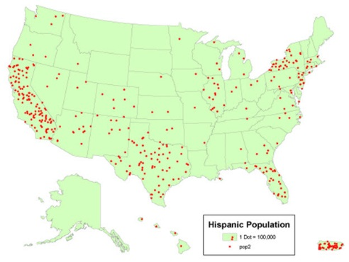
- Dot maps use identical dots to show how something is distributed across an area.
- Use the key to find out what quantity each dot represents
- Most dots – therefore most people are on the west coast. Clusters of dots show more people

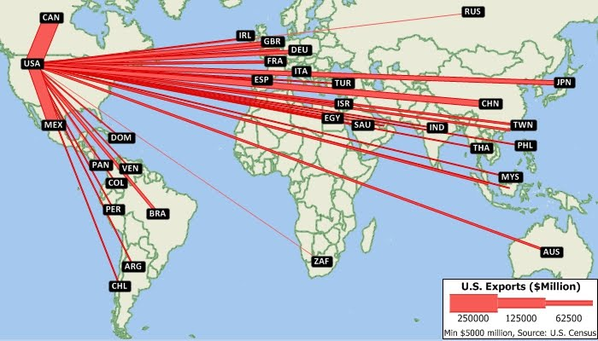
Desire lines show journeys
- Desire line maps are a type of flow line as they show movement too.
- They’re straight lines that show journeys between two locations, but they don’t follow roads or railway lines
- One line represents one journey
- They’re used to show how far all the people have travelled to get to a place.
Proportional symbol maps use symbols of different sizes
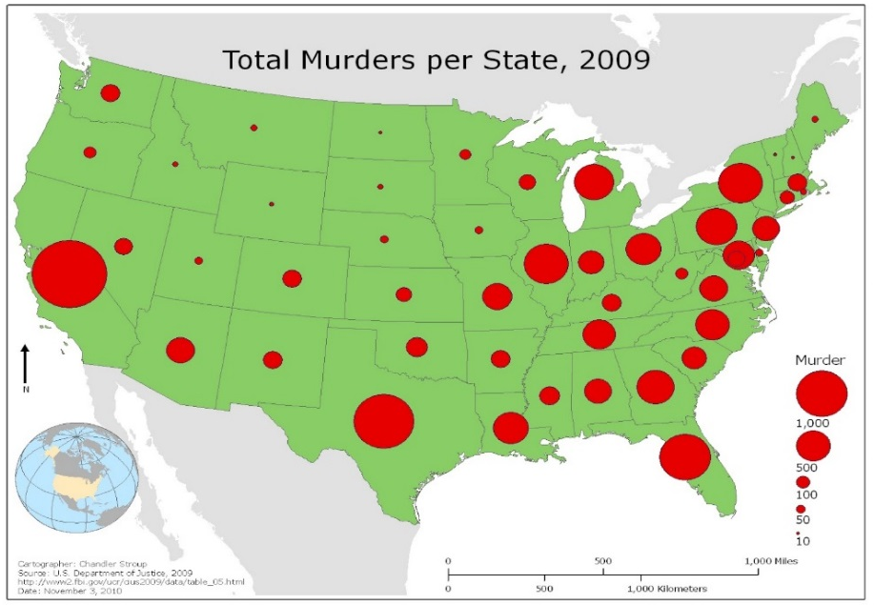
- Proportional symbol maps use symbols of different sizes to represent different quantities
- A key shows the quantity each different sized symbol represents. The bigger the symbols, the larger the amount
- The symbols might be circles, squares, semi-circles or bars but a larger symbol always means a larger amount

Flow lines show movement
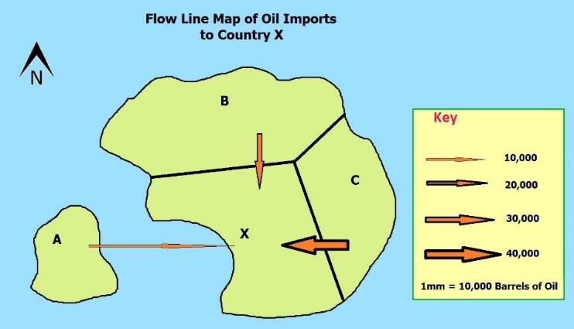
- Flow line maps have arrows on, showing how things move (or are moved) from one place another.
- They can also be proportional symbol maps – the width of the arrows show the quantity of things

Numerical skills

Statistical skills
Interquartile range
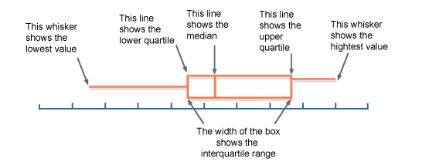
We know that the median divides the data into two halves. We also know that for a set of n ordered numbers the median is the (n + 1) ÷ 2 ^{th} value.
Similarly, the lower quartile divides the bottom half of the data into two halves, and the upper quartile also divides the upper half of the data into two halves.
Lower quartile is the (n + 1) ÷ 4 ^{th} value.
Upper quartile is the 3 (n + 1) ÷ 4 ^{th} value
Box and whisker plots
A box and whisker plot is used to display information about the range, the median and the quartiles. It is usually drawn alongside a number line, as shown:
Dispersion diagrams show the frequency of data
- Dispersion diagrams are a bit like a cross between a tally chart and a bar chart
- The range of the data that’s measured goes on axis. Frequency goes on the other axis
- Each dot represents one piece of information – the more dots there are in a particular category, the more frequently that event has happened
- The dispersion diagram to the right shows the % of household waste that’s recycled for households in a particular village

Strengths and weaknesses of different data presentation methods
Name of data presentation method | Strength | Weakness
Bar | Easy to draw and understand  Good visual representation of statistical data | Graph categories can be recorded to emphasise certain effects  Use only with discrete data
Squatter graphs | It will show you a correlation between two data sets  Relatively easy to construct  Shows data spread clearly and any animalises stand out | Too many datapoints can produce skewed results producing incorrect graph analysis  Too many data points can quickly make the graph unreadable
Pie charts | Shows % of each segment  Easy to draw  Can represent a wide range of statistical data | Too many segments make the graph hard to read  No exact numerical data just %
Isoline maps | Data can be represented without artificial area boundaries. Therefore changes in value occur  This makes maps useful for interpreting general trends in distribution | Can be difficult to construct  Element of guesswork involved in the position of the isolines between values. This makes them rather subjective, especially if there is a lack of known values.
Dot maps | Good visual representati0on of distributions | Lacks precise location and value of each individual item
Choropleth map | Visually effective, you can see clear spatial patterns | The whole of an area with one shading pattern appears to have the same density with no variations in it , but in reality this is not the case and there will be variation within each area

Fieldwork
Fieldwork: Human Geography
Aim of enquiry:

Geographical theory – The Burgess Model – Land use model
CBD | Inner city
Inner suburbs | Outer suburbs
Rural-urban fringe

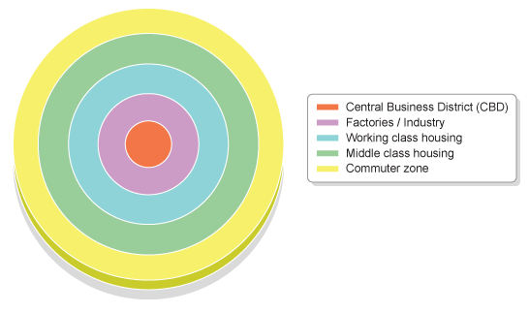
Central Business District
Inner city
Inner suburbs
Outer suburbs
Rural-urban fringe

Secondary data: | Maps & photographs:
Risks:  Advantage of location: | Description of method:
Justify the method: | Data presentation:  .
Results:
Site | Paint finish | Quality of garden | Available parking | Quality of roof and brickwork | Security features | Overall score | Average
Site 1 – CBD | 0 | 0 | 0 | 2 | 2
Site 2 – Inner city | 1 | -2 | -1 | -2 | 0
Site 3 – Suburbs | 1 | 2 | 2 | 1 | 0
Site 4 – RUF | 2 | 2 | 2 | 1 | 1

Description of the results:
Site 1 – CBD:

Site 2 – Inner city:

Site 3 – Suburbs:

Site 4 – RUF:

Conclusion:

Evaluation: Problems
Issues with the methods: Solutions:

Issues with the results: Solutions:

Conclusion
It is valid because………..

It is not valid because………….

Fieldwork: Physical Geography
Aim of enquiry (title of physical fieldwork enquiry):
How does discharge vary down Burbage Brook?

Geographical theory – Diagrams of cross profile  Describe the valley and channel shape:  Upper course:  Middle course:  Lower course: | Geographical theory -  A river will get………………… downstream which  means the river will ………………………. up because  there will less…………………with the banks. This  means that the river is more efficient.
Advantage of location:  Easy to get to: good roads mean…..  All public footpaths: | Risk assessment:  Getting lost:  Trip or fall:  Extreme weather:
Description of method:  This should be done in order:  1: | Justifying the method:  We measured a 10m distance because….  We did the experiment 3 times because……  One person dropped the ball and one person timed. This was more accurate because….
Maps & photographs:

We used maps because…..

We used photographs to…….
Data presentation method – Simple line graph:  - How did you draw your line graph: | Justification of data presentation method:  Effective:  Not effective:  Overall opinion:
Data analysis - Results
 | Width | 1 | 2 | 3 | Mean
Upper | 1.4m | 20 | 19 | 20
Middle | 3.0 | 15 | 19 | 19
Lower | 6.0 | 10 | 9 | 8

Conclusion:

Evaluation: Problems and solutions

 | Problem | Solution
Method
Results
Conclusion

Practice fieldwork questions:
1-4 mark questions
State the title of your fieldwork enquiry in which human geography data were collected:
……………………………………………………………………………………………………………………………………………………….
State the title of your fieldwork enquiry in which physical geography data were collected:
……………………………………………………………………………………………………………………………………………………….
Remember these can be changed in these questions
Explain why it was a suitable title for a fieldwork enquiry (2)
Explain one factor you considered when selecting a suitable questions/hypothesis for you human geography enquiry about the place (2)
Explain why you selected a secondary source as part of your enquiry (3)
Justify one method of data collection that you decided to use (2) – Human geography
Justify one method of data collection that you decided to use (2) – Physical geography
Justify the sampling technique you used in one of your enquires (3)
Explain one way you summarised/collated your primary fieldwork data (2)
For one of your enquires, explain one reason why you selected a specific data presentation method. (2)
Justify the use of one type of graph used in your human geography enquiry (2)
Justify why you used a map (cartographic), photograph or sketch map used in your enquiry (3)
Explain one method that you used to analyse your primary fieldwork data (2)
Explain one problem that you encountered in your data collection (2)
Explain how the time of day or year of your physical geography fieldwork enquiry may have affected your results (3)
For one of your enquiries, explain how your sample size may have affected the reliability of your conclusions (2)
6 mark questions
Describe the method(s) you used in your physical geography enquiry (6)
Describe the method(s) you used in your human geography enquiry (6)
Assess the effectiveness of your data presentation methods that you used in this enquiry (6)
Assess the effectiveness of one technique you need to analyse your fieldwork data in your human geography enquiry (6)
To what extent did your primary data help to support your conclusion(s) (6)
Assess the strength of the conclusions that you were able to draw from your fieldwork (6)
9 mark questions
Referring to one of your enquiries, assess the extent to which you were successful in collect primary data. (9 & 3 SPaG)
With reference to data presentation methods used in one of your enquires, explain to what extent these helped you to interpret your fieldwork data (9 & 3 SPaG)
With reference to one of your fieldwork enquiries, suggest how you could have improved the presentation of your data (9 & 3 SPaG)
With reference to one of your fieldwork enquires, assess the extent to which your conclusions matched your expectations at the start of your enquiry (9 & 3 SPaG)
Referring to one fieldwork investigation you have carried out, assess the range of additional data that could have been used to improve your data (9 & 3 SPaG)
Referring to one fieldwork investigation you have carried out, assess the problems that you faced with your method(s) of data collection (9 & 3 SPaG)

