Q1.
Which term is best defined by the phrase, ‘the increasing percentage of the population living in towns and cities’?
Shade one circle only.

A | Urban sprawl
B | Urbanisation
C | Migration
D | Urban regeneration
(Total 1 mark)
Q2.
Study the graph below showing the percentage of the population living in urban areas in different parts of the world 1950–2050 (projected).
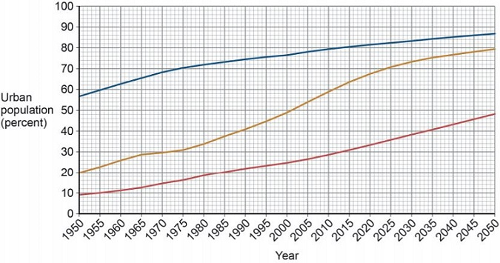
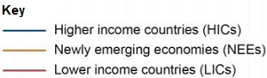
Complete the following paragraph to describe the changes shown in the graph above.
Choose the three correct answers from this list:
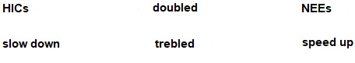
The smallest increase in percentage of urban population 1950–2050 is expected to be in
____________________.
From 2020 the rate of increase is expected to ____________________ in NEEs.
Between 2000 and 2050, lower income countries are projected to have almost
____________________ in the percentage living in urban areas.
(Total 3 marks)
Q3.
Study the graph below showing GCSE scores along a transect through a UK city.
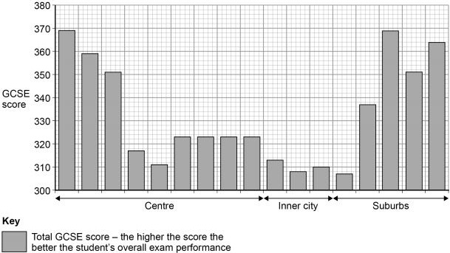
(a) Calculate the range in GCSE scores shown in the graph above.
___________________________________________________________________
___________________________________________________________________
(1)
(b) Using the graph and your own understanding, suggest reason(s) for inequalities in education in urban areas in the UK.
___________________________________________________________________
___________________________________________________________________
___________________________________________________________________
___________________________________________________________________
___________________________________________________________________
___________________________________________________________________
___________________________________________________________________
___________________________________________________________________
(4)
(Total 5 marks)
Q4.
Outline one way that national migration has led to change in the character of a named UK city.
_______________________________________________________________________
_______________________________________________________________________
_______________________________________________________________________
_______________________________________________________________________
(Total 2 marks)
Q5.
Evaluate the effectiveness of an urban planning strategy in helping to improve the quality of life for the urban poor.
Use an example of a city in a lower income country (LIC) or newly emerging economy (NEE).
(Total 9 marks)
(+ 3 SPaG marks)
Q6.
To what extent do urban areas in lower income countries (LICs) or newly emerging economies (NEEs) provide social and economic opportunities for people?
_______________________________________________________________________
_______________________________________________________________________
_______________________________________________________________________
_______________________________________________________________________
_______________________________________________________________________
_______________________________________________________________________
_______________________________________________________________________
_______________________________________________________________________
_______________________________________________________________________
_______________________________________________________________________
_______________________________________________________________________
_______________________________________________________________________
(Total 6 marks)
Q7.
Study the photograph below showing part of a squatter settlement.
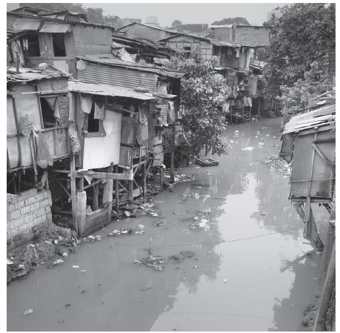
(a) On the picture above, mark with an arrow and label three characteristics of this squatter settlement.
(3)
(b) Suggest how one or more of the conditions shown in the figure above affects the lives of the people living there.
___________________________________________________________________
___________________________________________________________________
___________________________________________________________________
___________________________________________________________________
___________________________________________________________________
___________________________________________________________________
(4)
(Total 7 marks)

Mark schemes
Q1.
One mark for the correct answer:
B: Urbanisation.
AO1 = 1 mark
[1]
Q2.
One mark for each correct word or number.
The lowest increase in proportion of urban population 1950 – 2050 is expected to be in HICs. From 2020 the rate of increase is expected to slow down in NEEs. Between 2000 and 2050 lower income countries are projected to have almost doubled the percentage living in urban areas.
AO4 = 3 marks
[3]
Q3.
(a) One mark for the correct answer:
62 (369 - 307)
AO4 = 1 mark
(b)

Level | Marks | Description
2  (Clear) | 3 – 4 | AO2 – Shows clear understanding of the concept of inequality in urban areas of the UK.  AO3 – Uses the graph showing GCSE scores and offers development to interpret the links between urban areas and processes and increased inequality in education.
1  (Basic) | 1 – 2 | AO2 – Shows limited understanding of the concept of inequality in urban areas of the UK.  AO3 – uses the graph showing GCSE scores OR own understanding to begin to interpret the links between urban areas and processes and increased inequality in education.
 | 0 | No relevant content.
• Level 2 (clear) responses will apply geographical understanding in combination with the graph to present a reasoned explanation.
• Level 1 (basic) responses will be simplistic or simply assert a cause / effect link.
Indicative content
• Answers should make use of the graph showing GCSE scores which could be clear through reference to data from the Figure or more implicit through reference to city centre / inner city. Development need not be through named places but use of a case study is likely to add clarity. Development may also be found in explanation of processes of change and widening gaps in cities.
• Candidates may refer to a range of processes of change and may achieve full marks through full development of one:
• De-industrialisation leading to inner city decline and subsequent deprivation leading to poorer education in inner areas, e.g. Leyton / Stratford chosen as the Olympic Site as the most deprived areas in the UK.
• Deprivation and change tend to be cumulative such that areas will also have lower employment levels, poorer health, lower incomes and poorer educational outcomes.
• Urban change has gone hand in hand with this so that those on higher incomes either create wealthy enclaves in the centre or are able to move to the outskirts; accessing better housing, employment and healthcare; leaving behind a more elderly and disadvantaged population, worsening the situation above.
• Credit those who discuss inner city / suburban differences, with the requirement to use the graph to reach level 2.
• It would also be possible for candidates to argue that targeted education programmes in inner city areas e.g. City Academies have improved the situation so that GCSE scores in some central London wards for example are amongst the best in the country.
Max L1 for non-UK answer if the comments could still apply.
Max L1 for general description of inequalities in urban areas.
No credit for description of the inequalities in education in isolation as this is shown on the graph.
AO2 = 2 marks
AO3 = 2 marks
[5]
Q4.
Credit one migration and consequent change only.
One mark for a basic statement, e.g.
• Migration from elsewhere in the UK means many cities have had to build large new housing estates (1)
• Birmingham is the most popular city for people leaving London so its population is growing again after recent decline (1).
Two marks for a developed idea, e.g.
• Migrants create a need for more housing often built on the outskirts (1) such as Croxteth Park, Liverpool which lead to urban sprawl / loss of individual character (d)(1)
• Migration may have added to an increase in underground passengers in London (1). As a result a majority of passengers now regard commuting as stressful and say it spoils the city (d)(1).
Max 1 mark if city not named or clearly able to be inferred.
No credit if the migration is not national, at least implicitly, or the change does not relate to character, at least in inference.
AO1 = 2 marks
[2]
Q5.

Level | Marks | Description
3  (Detailed) | 7 – 9 | AO1 Demonstrates detailed knowledge of urban planning strategies and how they can improve the quality of life for the urban poor in a LIC or NEE.  AO2 Shows thorough geographical understanding of how urban planning strategies can improve the quality of life for the urban poor in a LIC or NEE.  AO3 Demonstrates sound application of knowledge and understanding in a reasoned way in evaluating the effectiveness of planning strategies in helping to improve the quality of life for the urban poor in a LIC or NEE.
2  (Clear) | 4 – 6 | AO1 Demonstrates clear knowledge of urban planning strategies and how they can improve the quality of life for the urban poor in a LIC or NEE.  AO2 Shows some geographical understanding of how urban planning strategies can improve the quality of life for the urban poor in a LIC or NEE.  AO3 Demonstrates some application of knowledge and understanding in evaluating the effectiveness of planning strategies in helping to improve the quality of life for the urban poor in a LIC or NEE.
1  (Basic) | 1 – 3 | AO1 Demonstrates limited knowledge of urban planning strategies and how they can improve the quality of life for the urban poor in a LIC or NEE.  AO2 Shows limited geographical understanding of how urban planning strategies can improve the quality of life for the urban poor in a LIC or NEE.  AO3 Demonstrates limited application of knowledge and understanding and makes a simple evaluative statement about the effectiveness of planning strategies in helping to improve the quality of life for the urban poor in a LIC or NEE.
 | 0 | No relevant content.
Indicative content
• Example must be drawn from a lower income country or a newly emerging economy.
• The term ‘urban planning strategy’ can be interpreted in the broadest sense and include local government schemes, self-help schemes and NGO schemes.
• Strategies can be holistic and include a number of socio-economic and environmental elements or be focused on particular elements of improvement, for example community development schemes or housing improvement schemes, water / sanitation improvement schemes.
• ‘Evaluate the effectiveness’ implies an understanding of what the conditions were like before and a judgement about the extent to which the conditions have improved.
• A descriptive account of a particular strategy with no reference to how it has changed conditions will generally not get beyond Level 1.
AO1 = 3
AO2 = 3
AO3 = 3
Spelling, punctuation and grammar (SPaG)
High performance
• Learners spell and punctuate with consistent accuracy
• Learners use rules of grammar with effective control of meaning overall
• Learners use a wide range of specialist terms as appropriate
3
Intermediate performance
• Learners spell and punctuate with considerable accuracy
• Learners use rules of grammar with general control of meaning overall
• Learners use a good range of specialist terms as appropriate
2
Threshold performance
• Learners spell and punctuate with reasonable accuracy
• Learners use rules of grammar with some control of meaning and any errors do not significantly hinder meaning overall
• Learners use a limited range of specialist terms as appropriate
1
No marks awarded
• The learner writes nothing
• The learner‘s response does not relate to the question
• The learner‘s achievement in SPaG does not reach the threshold performance level, for example errors in spelling, punctuation and grammar severely hinder meaning
0
[+ 3 SPaG marks]
[12]
Q6.
Level | Marks | Description
3  (Detailed) | 5–6 | AO3 Demonstrates thorough application of knowledge and understanding to the issue of opportunities for people in urban areas in LICs and/or NEEs.  AO3 Demonstrates reasoned evaluation of the extent to which urban areas in LICs or NEEs provide social and economic opportunities for people.
2  (Clear) | 3–4 | AO1 Shows clear and accurate knowledge of places and processes in urban environments.  AO2 Demonstrates sound understanding of how urban areas provide both social and economic opportunities.
1  (Basic) | 1–2 | AO1 Shows limited and partially accurate knowledge of places and processes in urban environments.  AO2 Demonstrates some understanding of how urban areas provide both social and/or economic opportunities.
 | 0 | No relevant content.
Indicative content
• Emphasis should be placed on social and economic opportunities. No direct credit for environmental aspects unless they impinge on living standards/economic opportunities.
• The command ‘to what extent’ requires an appraisal of the degree to which urban areas in LICs/NEEs provide social and economic opportunities for people.
• Answers may refer to a named city (although this is not essential) such as Rio de Janeiro in Brazil where people can earn more money and have regular jobs. Construction provides a big source of employment for large numbers of unskilled workers, and many work in manufacturing, such as food, and making shoes and textiles. People can then afford to have better housing, which includes a clean water supply, sanitation and electricity. This increases the chance of a healthier life and reduces the risk of disease.
• Urban areas also have education and health opportunities; children can go to school, which gives them a better opportunity to get a job.
• Credit responses which take the view that opportunities are restricted and that there is often a mismatch between perceived opportunities and the reality of life in urban areas in LICs or NEEs. Unplanned urbanisation may bring risk of social instability, pressure on infrastructure, potential water crises and the potential for spread of disease.
• While moving to a city offers people more opportunities to improve their living conditions, the high cost of living and competition for jobs can also trap people in poverty.
• Rapid and unplanned urbanisation can also contribute to urban violence and social unrest, particularly where there is inequality, competition for resources such as land, and weak government.
• Responses may take a balanced view, recognising that there are both opportunities and challenges.
AO1 = 2
AO2 = 2
AO3 = 2
[6]
Q7.
This mark scheme is from a question paper that assessed a previous specification and has not been edited.
Click [here] to access a document explaining the differences that might apply to it.
(a) 3 × 1
Any valid labels. Label must point directly to the characteristic chosen, e.g. poor quality materials / construction; corrugated iron roofs; high density of housing; polluted / dirty water; poor waste disposal.
No arrows / label lines no marks.
AO2 = 1
AO3 = 2
(b) Credit elaboration through exemplars although they are not required. A wide range of responses are possible. Candidates could comment on the lack of safety and the danger of injury or death from the poorly built environment especially if natural hazard; the risk of diseases such as cholera and typhoid from the polluted water shown; diseases such as TB from the crowded conditions; depression and resentment amongst the residents and social unrest as a result.
AO1 = 2
AO2 = 2

Level | Marks | Description
2  (Clear) | 3 – 4 | Linked statement(s) showing some explanation of the link between characteristic(s) and effects on lives.  Because the houses are poorly built they could collapse and injure the people who live there. Clearly the dirty water will increase the risk of cholera, especially if there is no better water supply.
1  (Basic) | 1 – 2 | Simple statements with no clear connection between characteristic(s) and effect on lives.  People wouldn’t be happy to live there. There is a big risk of disease. The houses aren’t safe.
 | 0 | No relevant content.
[7]

