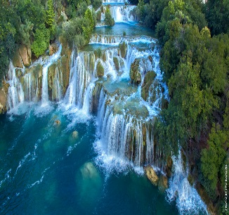
Year 7 Geography Revision Booklet:
March 2020

Name: __________________________ Teacher: _____________________
Revision checklist
You will have one week to complete this booklet. You can either download this booklet and edit it with your answers, or answer on a piece of paper and send it to your teacher once completed.

Section | What do I need to be able to do? | Can I do this? Please tick. (If not, speak to your teacher)
Map skills | - Label a compass
 | - Recognise map symbols
 | - Read four and six figure grid references
 | - Use compass directions to describe location on a map
 | - Identify features on an OS map
 | - Describe patterns using a map
Interpreting a graph | - Describe what a graph shows
 | - Complete a graph using data
 | - Interpret data from a graph – mean, median, mode, range etc.

Map skills
i) You need to know how to label a compass. Remember, a compass is used to show directions. Task) Complete the compass below with these missing words:
EAST NORTH-EAST SOUTH-WEST SOUTH
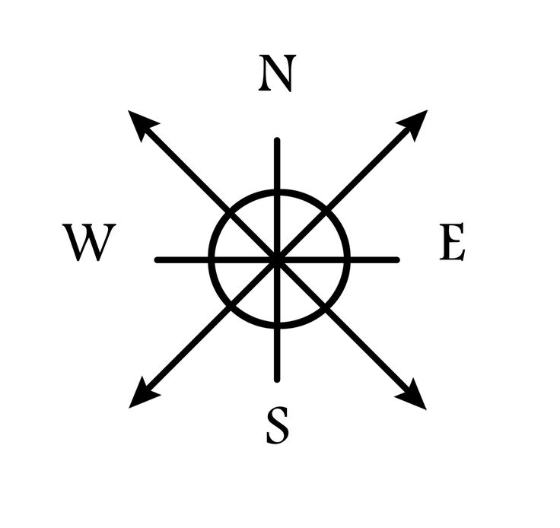
NORTH
SOUTH-EAST
WEST
NORTH-WEST

2. You also need to know how to use map skills when reading an OS map. Each map is split into grids/boxes. These are used to locate specific places on a map. A four-figure grid references is 4 numbers (2 along the bottom, 2 up the sides). A six figure grid reference uses the original two numbers, but then you split each grid/box into 10. You must always read along the bottom first, then up the side.
Example, Meadows is located in:
- 4 figure grid reference = (91,05)
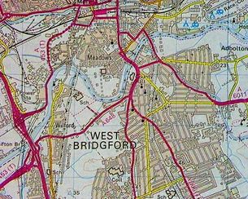
- 6 figure grid reference = (916,051)
Key:
Telephone
Viewpoint
Campsite
Caravan site
School
Post Office
Picnic site
Nature reserve
Information centre

04
05
06
91
92
93
90
03

2. i) Give the four and six figure grid reference for the following features on the OS map:
Sch: 4 figure grid reference = ( , ) 6 figure grid reference = ( , )
Sch: : 4 figure grid reference = ( , ) 6 figure grid reference = ( , )
A648: 4 figure grid reference = ( , ) 6 figure grid reference = ( , )

2. ii) What compass direction is ‘Meadows’ from the school? ____________________

2. iii) What compass direction is ‘West Bridgford’ from the campsite? ____________

2. iv) What other features are shown on an OS map? E.g. Major roads are shown as a red line.
____________________________________________________________________________________________________________________________________________________________________________________________________________________________________________________________________

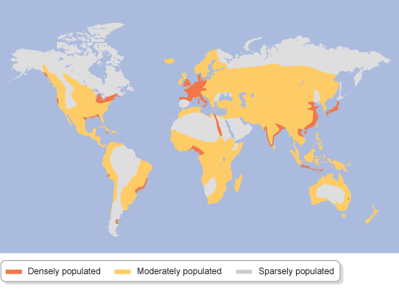
3. Below is a map of the world showing population density (number of people per km²). Using the map, decide which statements are true (T) or false (F).
Key terms:
Densely populated – lots of people per km²
Moderately populated – quite a few people per km²
Sparsely populated – very few people per km²
Statement | T or F
China is sparsely populated
South of the UK is densely populated
The majority of Russia is sparsely populated
The south-east of Brazil is densely populated
Central Australia is moderately populated
The coastal areas of India is densely populated
Interpreting a graph
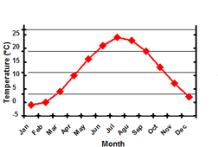
1. Fill in the gaps to describe the changes in temperature throughout the year using the line graph.

Overall, the graph shows that temperatures ________________ from January to July and they _____________ from August to December. Temperatures are at their lowest in ______________ at -3˚C, this is because it is _________ so temperatures are usually very low. Temperatures are at their highest in ______ at ___˚C, this is because the UK is in summer so temperatures are expected to be much __________. Overall, temperatures increase by _____˚C (biggest – smallest)
Missing words
JANUARY 23 INCREASE JULY
DECREASE HIGHER WINTER 20

2. Complete the bar chart below by adding the following:
Axis titles: Y axis = Average life expectancy (years) X axis = Countries
Data: Bolivia = 68 Uruguay = 77
- Which country has the highest life expectancy?
Answer: __________________
- Which country has the lowest life expectancy?
Answer: __________________
- What is the range (biggest-smallest)?
Answer: __________________
- What is the mean? (add all the numbers together and divide by 6))
Answer: __________________

