Year 8 Home Learning Workbook

|  |  |  |
| --- | --- | --- |
| Topic | Activity | Date to be completed |
| Blitz | List all you can! |  |
| Blitz | Highlighter activity |  |
| Evacuation | Question activity |  |
| Dunkirk | Question activity  Exam style question |  |
| Battle of Britain | Table activity |  |

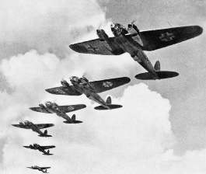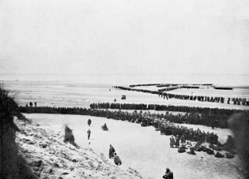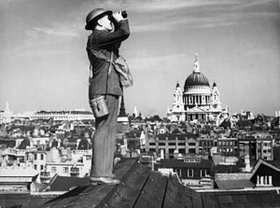

Exam top tips:

Watch out for SPAG and remember to include specialist terminology

When writing a conclusion, give good detail, summarise your arguments and come to a judgement…its really worth it!

Remember to keep an eye out for the clock symbol! It will keep you focused on the amount of time you can spend on the question!

List as many things as you can about:

**The Blitz!**

The German bombing of British cities was known as ‘The Blitz’. The aim of the Germans was to bomb industrial targets and civilians. This was to disrupt the production of bombs and bullets and to try to force the British people into surrender. The Blitz began with attacks on London on September 7th 1940. The German air force, known as the Luftwaffe, dropped 5,300 tonnes of high explosives on London in just 24 nights.

The British people had been warned that air attacks on cities were likely and began getting ready. Sirens were installed to warn people that the bombers were coming and to give them time to get to shelter to stay safe during the attacks.

Many people went to air raid shelters to keep safe from the bombing. Those with gardens built simple shelters from steel, known as Anderson shelters, covered by earth. Shelters built from brick and concrete were built in towns and cities for people to shelter in. Those in London even used the underground train stations to shelter in! During the Blitz, the government enforced a blackout. This was to make sure lights were turned off at nights so German bombers couldn’t see the cities below them during attacks at night.

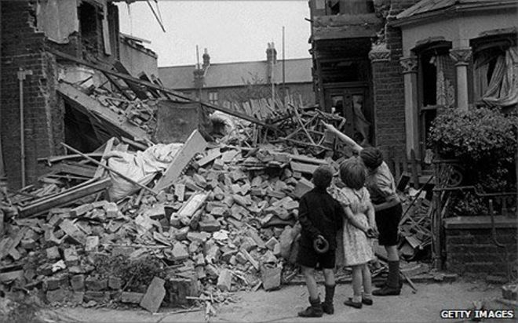Groups of people were evacuated from cities that were being heavily attacked by the Germans. These people were vulnerable and most at risk from the attacks. Children were evacuated away from the cities, often being sent away from their families, to live in the countryside with strangers. Groups of mothers were also evacuated; pregnant women along with mothers with children under five were also evacuated. Disabled people and the elderly were also vulnerable from attacks and sent away from the cities. Even teachers were evacuated!

Word Bank

**Industrial targets:** factories that were making bombs and bullet for the British army to help fight the Germans.

**Civilian:**Just normal people who weren’t in the army

Highlight the following:

What the Blitz was

The groups who were evacuated

+

+

+

How people stayed safe during the  
Blitz

Top Tip: Don’t just highlight everything! This is to help with revision!

Read these sources and answer the questions which follow:

#### Interpretation A: Children evacuated to Oxford and Cambridge were asked to write essays explaining what they liked and disliked about their new homes. This is an extract from one of these essays written by a thirteen year old girl.

There isn't much that I really like in Cambridge. I like the meadows and parks in the summer but it is too cold in the winter to go there. I miss my home in Tottenham and I would rather be there than where I am. I cannot find much to do down here. I miss my sister and my friends. I haven't any of my friends living in Newnham (Cambridge) where I live and I never know where to go on Saturday and Sunday as I have no one to go with.

#### Interpretation B: A letter sent from an evacuee to his parents still in the cities.

#### Dear Mum,

#### I hope you are all right. Tomorrow morning we have got to bring in some pees for nature study. I am knitting a pair of slippers in pink and blue wool. It is nice down here. I expect you would like to come down here. Joy and I went for a walk. I got all my pees. I bought a little doll down here. I have met a friend called Jack. He is very nice. He has lived here all his life and is showing me around.

#### With love from Pam.

Which source is positive about the experiences of being evacuated? Why do you think this?

……………………………………………………………………………………………………………………………………………………………………………………………………………………………………………………………………………………………………………………………………………………………………………………………………………………………………………………….

Which source is negative about the experiences of being evacuated? Why do you think this?

………………………………………………………………………………………………………………………………………………………………………………………………………………………………………………………………………………………………………………………………………………………………………………………………………………………………………………………

**How does interpretation A differ from interpretation B about evacuation? Explain your answer using ideas from interpretation A and B. [4 marks]**

You should find **2 differences** between the sources.

You should explain how they are different

Difference One:

Interpretation A states………………………………………………………………………………………………………  
…………………………………………………………………………………………………………………………………………………………………………………………………………………………………………………………………………………………………….However, interpretation B states that…………………………………………………………………………...  
…………………………………………………………………………………………………………………………………………………………………………………………………………………………………………………………………………………………………….

Now you must include some knowledge about the evacuations to back up your points!

From my own knowledge, I know that……………………………………………………………………………...  
…………………………………………………………………………………………………………………………………………………………………………………………………………………………………………………………………………………………………….

Difference Two:

Remember to look out for ! This will tell you the amount of time to spend on this question!

Interpretation A states………………………………………………………………………………………………………  
…………………………………………………………………………………………………………………………………………………………………………………………………………………………………………………………………………………………………….However, interpretation B states that…………………………………………………………………………...  
…………………………………………………………………………………………………………………………………………………………………………………………………………………………………………………………………………………………………….

Now you must include some knowledge about the evacuations to back up your points!

From my own knowledge, I know that……………………………………………………………………………...  
……………………………………………………………………………………………………………………………………………….…………………………………………………………………………………………………………………………………………………….

Remember to look out for ! This will tell you the amount of time to spend on this question!

**Impact of the Blitz**

The Blitz had a major impact on the people of Britain. Families were one of the most affected groups in Britain. The Second World War brought many changes to the lives of children in Britain. For some, the war was a time of fear and confusion that meant separation from families. Evacuation was the biggest cause of disruption to children’s lives. A government scheme saw millions of children in Britain sent to places of safety for fear of German bombing. Many families made their own arrangements to evacuate their children to friends and family in the country. Children’s education suffered during the war. One in five of the country’s schools were damaged by bombing and many others were taken over by the government. Children were crammed into large classes and stationery and books were often in short supply.

Families also had to shelter away from the bombing. Anderson Shelters were dark and damp and people were reluctant to use them at night. In low-lying areas, they tended to flood and sleeping was difficult as they did not keep out the sound of the bombings. Public shelters were also used. The government passed laws that attempted to control people's behaviour in air raid shelters. If someone was found to "wilfully disturb other people he could be sent to prison. In December 1941, fifty-three-year-old George Hall was sent to prison under this law. In fact, he was only guilty of snoring in a shelter!

The Ministry of Food was responsible for overseeing rationing. Every man, woman and child was given a ration book with coupons. These were required before rationed goods could be purchased. Basic foodstuffs such as sugar, meat, fats, bacon and cheese were directly rationed by an allowance of coupons. As shortages increased, long queues became commonplace. It was common for someone to reach the front of a long queue, only to find out that the item they had been waiting for had just run out.

The Blitz had other major impacts on the lives of people during the Blitz. Blackouts, homes destroyed, people unemployed because of a factory having been destroyed by a bomb were all common place.

**EXAM STYLE QUESTIONS**

In what ways were the lives of children affected by the Blitz? (8 marks)

Things to remember to get top marks!!

1. Choose two impacts on children and explain them well!
2. Then think about how the Blitz impacted on other things! E.g. factories being destroyed so there were less bombs and bullets available for the army fighting the Germany

Read through the information above

Underline the impacts of the Blitz on people.

Challenge: can you think of any other impacts the Blitz had on Britain?

Make up 5 questions on the Blitz and then get someone to test you

1.

2.

3.

4.

5.

6.

Answers

1.

2.

3.

4.

5.

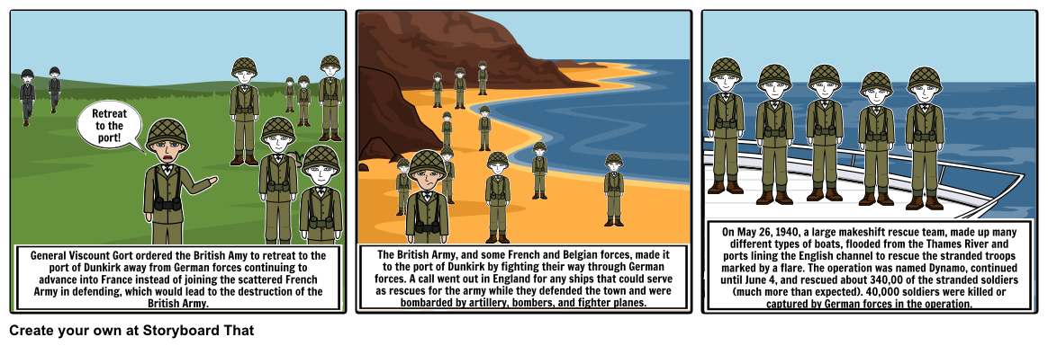**Dunkirk**

Dunkirk, and the evacuation associated with the troops trapped on Dunkirk, was called a “miracle” by Winston Churchill. As the Wehrmacht swept through Western Europe in the spring of 1940, using Blitzkrieg, both the French and British armies could not stop them.

The advancing German Army trapped the British and French armies on the beaches around Dunkirk. 330,000 men were trapped here and they were a sitting target for the Germans. Admiral Ramsey, based in Dover, formulated Operation Dynamo to get off of the beaches as many men as was possible. The British troops, led by Lord John Gort, were professional soldiers from the British Expeditionary Force; trained men that we could not afford to lose. From May 26th 1940, small ships transferred soldiers to larger ones which then brought them back to a port in southern Britain.

The beach at Dunkirk was on a shallow slope so no large boat could get near to the actual beaches where the men were. Therefore, smaller boats were needed to take on board men who would then be transferred to a larger boat based further off shore. 800 of these legendary “little ships” were used.

Read through the information above

Summarise what happened at Dunkirk in 5 sentences

1.

2.

3.

4.

5.

Was Dunkirk a victory? Yes/No

Source A

Even though the troops have been evacuated from Dunkirk, Hitler had scored a crushing victory. 10,252 Germans had been killed, 42, 523 wounded and 8467 were missing. However, Hitler announced that 1,212,000 Dutch, Belgian, French and British prisoners had been taken. In addition, he said that his armies had captured from the British 2100 field guns, 1250 anti-aircraft guns, 11,000 machine guns and 75,000 vehicles.



**Interpretation A does not see Dunkirk as a victory for the British. How do you know this from studying the source?** Explain your answer by using Interpretation C and your own knowledge. (6 marks)

Interpretation A describes…………………………………...........…………………………………………..…………………......

…………………………………………………………………………………………………………………………..………

……………………………………………………………………………………………………………………………..……

This suggests that Dunkirk was .....…………………………………………………………………..  
…………………………………………………………..……………………………………………………………………..

The source is created by a…………………………………………………………………... and written in …………………….. This means that…………………………....……………………….  
……………………………………………………………………………………………………………………………………………………………………………………………………………………………………………………………………

The interpretations also states that……….…..………………………………………………  
…………………………………………………………………………………………………………………………………………………………………………………………………………………………………………………………..………  
From my own knowledge, I know that…………………………………………………………….  
………………………………………………………………………………………………………………………………..  
………………………………………………………………………………………………………………………………….  
………………………………………………………………………………………………………………………………….

Give an overview of the interpretation!

Does this suggest that Dunkirk was a failure?

How might the author impact on the interpretation?

Is he making propaganda? Has he all the facts?

Include your historical knowledge to comment on the source!

Take another quote from the source

**The Battle of Britain**

In order to invade Britain, the Germans had to have control in the air over the English Channel, otherwise the Royal Air Force (RAF) and the Royal Navy would have been able to destroy their invasion force before it reached the shore. The Luftwaffe's command of the air was therefore vital to any plan for an invasion fleet to successfully cross the Channel, to prevent British sea or air forces from interfering with the operation. At the beginning of August, with German invasion forces and troop barges being assembled on the French coast, the raids against the South coast of England were increased in size and number.

Believing that the British early warning system (this was a warning system for when German planes were approaching) had been destroyed and the coastal towns sufficiently 'softened up' for an invasion, the Luftwaffe began the next stage of their plan.

On 13 August, massive raids began on the airfields of the RAF. The aim was to destroy the RAF, either in the air or on the ground, in South East England. To put pressure on the British defences, the Germans sent high and low level raids to different targets at the same time.

This pattern continued into September and the situation for the RAF became desperate. Small civilian airfields were used in the emergency, as many RAF stations became badly damaged. The Spitfire and Hurricane (planes used by the RAF) could easily take off from grass fields, but the maintenance and spares supply, for repairs, became dangerously stretched. Ground crews working in the open suffered heavy casualties from the raids, and many maintenance facilities were destroyed in the bombing. Despite this, the crews kept the fighters as combat ready as possible, winning the battle on the ground as the pilots were in the air.

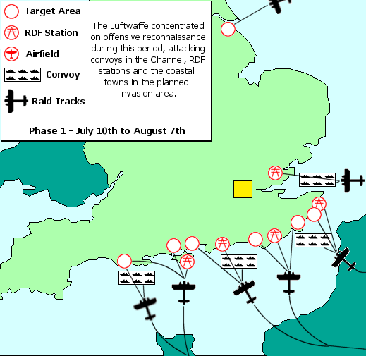Suggestions were made that the fighters should be pulled back north of the Thames, but the British knew that this was exactly what the Germans wanted, effectively giving them air superiority over the intended invasion area. So the RAF stayed and fought for their lives. To keep up the pressure, the Germans began night raids, to stop the defenders repairing damage overnight.

Just when it seemed that the country, and the RAF in particular, couldn't continue for another day, the Germans changed their tactics.

On a spare piece of paper, create a table and label the columns ‘British strengths’ and ‘German weaknesses’ and sort the following into that table!

|  |  |  |
| --- | --- | --- |
| British pilots only had short periods of rest while the planes were refuelled | British planes could land and take off from planes. When their landing strips were damaged, Spitfires and Hurricanes could still be used | The German planes could only fly for 30 minutes at a time. |
| The German planes flew in groups which made them easy targets | It took roughly 5 minutes for the Messerschmitt (the German plane) to across the Channel | The British fighter planes were faster and could move better than the German planes |
| Britain had RADAR. This meant that the British knew where the Germans would be attacking and could meet them and stop them | The British had been planning to defend against German attacks since 1936. They already had a plan and therefore could spend more time on other things like organising defences. | British pilots also had the advantage of flying over Britain- if they bailed out of their planes, they could be found by local people, looked after and could be back in the air very soon. |