Unit 2: Promoting Children’s Development Through Play
Learning Aim A: Understand how play promotes children’s development in early years settings.
P1 Describe how children play at each age range, using appropriate examples
P2 Describe how adults in early years settings support children’s play at each age range, using appropriate examples
M1 Explain the importance of the support provided by adults in early years settings for children’s play at each age range
D1 Assess the suitability of the support provided by adults for children in an early years setting, using a case study
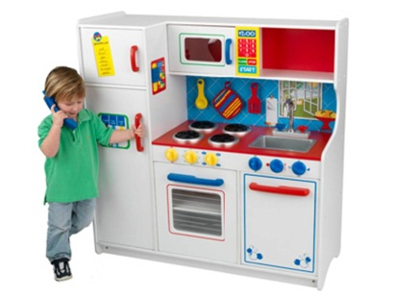
P1 Describe how children play at each age range, using appropriate examples
How would you define ‘play’?

Definition of play from internet – with website reference:

What do you think are the benefits of play?

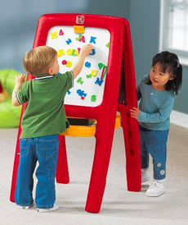
Types of play
Sometimes individual children like to play alone and sometimes they enjoy playing with others. Explain in your own words what these stages/ types of play are:
- Solitary play

- Spectator play

- Parallel play

- Associative/partnership play

- Co-operative play

Explain why children will begin these different types of play/stages of play at different ages. For example what skills or areas of development do they need before being able to take part in these types of play?

As babies, toddlers and young children learn and develop their play with others becomes increasingly intricate and complex.
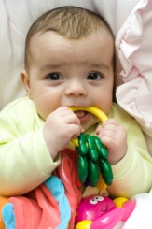
How children play from birth up to 2 years
Reliance on adults | Moving and touching | Repeating play
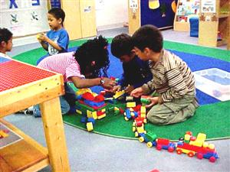
How children play from 2 up to 5 years
Being with other children | More complex play | Talk during play | Adult supervision and support

How children play from 5 up to 8 years
Being more independent | Making up rules | Increasingly complex play

Put the below statements about the types of play children engage in into the table in the age range they best match.
Birth up to 2 years | 2 up to 5 years | 5 up to 8 years
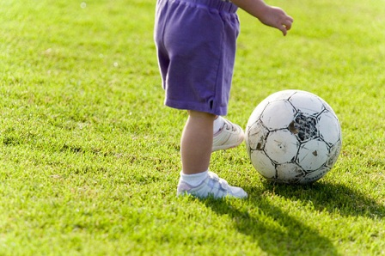
- Reliant on adults
- Begin to play side by side
- Like to watch other children play
- Makes up rules
- Enjoy kicking balls and climbing
- Begin to take it in turns
- Enjoy making decisions about their play
- Repeat an activity
- Put objects in their mouth

Extension
Add the below types of play into the age categories above:
- Solitary play
- Spectator play
- Parallel play
- Associative/partnership play
- Co-operative play

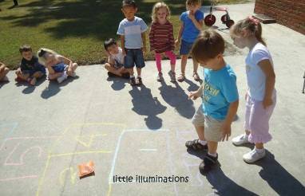
Case study
Miriam, Stephen, Mark and Ewan are great friends. They are in their second year at school. They cannot wait to go out and play every break and lunchtime. They have favourite games and at the moment their play is influenced by a television game show. There are other groups of children also playing a similar version of the same game. Another child comes and asks if he can join in. The children decide that he can and start to explain the rules. The game requires extra children to run with a ball, throw it to a partner and then get back to a bench without being caught. The game is very exciting and occasionally an adult has to intervene to stop it from becoming unsafe.
- Explain why their play is typical of their age

- Give two reasons why adults might have to intervene in this type of play

- Identify the links between the children’s social development and the way that they play.

Just checking
- Can you think of two ways in which a baby might play?

- Why is it important to recognise the play needs of different ages of children?

- Can you think of two features of children’s play at 4 years old?

- Can you think of two examples of how children aged 5-8 might play?

- Why is play thought to be good for children’s overall development?

Learning Objective A: Understand how play promotes children’s development in early years setting
Age appropriate play for babies up to 2 years
Children rapidly learn to play through their own actions and their contact with people around them. Babies often play by interacting with adults who talk, sing, and laugh with them, and help them explore the world around them.
Infancy is a good time for adults to begin reading and enjoying picture books with children. Adults can also listen to different kinds of music with babies and sing to them.
Babies benefit from floor time when they can safely roll around and explore. Once a baby begins to crawl, toys that can be pushed or rolled and chased across the floor encourage physical activity and interaction with other people. Toys for infants should appeal to their different senses. Babies enjoy seeing a mobile hanging over their beds and pictures on the walls. They can begin to handle safe toys—soft ones to feel and chew on, and toys that rattle and make other sounds. Toys need to be safe to chew because many babies explore with their mouths.
Toddlers are continuing to develop both small and large motor skills. They enjoy manipulating objects—for example, putting things into a container and then dumping them out. They can also learn from messy play with water, sand, and soft clay or play dough. Many playful art activities support fine motor skills and encourage children’s creativity. They can begin to use large paint brushes, washable (nontoxic) paints, and crayons meant for beginners. Toddlers require close supervision and safe play materials in case they decide to taste them!
At this age, children’s interest in musical play often increases. Toddlers can begin to sing songs with adults or make their own music. Pots and pans make great percussion instruments! Toddlers may want to move with the music and begin to dance.
Toddlers also need opportunities for large muscle play. They enjoy bouncing, rolling, and throwing balls of different sizes, jumping on pillows, or making a house or fort out of a cardboard box. With supervision, toddlers can go outdoors for walks, play on climbing and riding toys, and use playground equipment sized for them.
Playing with adults or with other children can help toddlers’ social and emotional growth and their language development. Taking turns with toys and taking turns while speaking during play can help toddlers see how to get along with others, and help them understand the “rules of conversation” that are basic to communication and language development.
Although they are busy exploring what’s around them, some toddlers show increasing interest in looking at picture books themselves or having someone read to them. Other toddlers may not want to sit and share a book yet because they are too busy investigating their world in other ways. Parents can try reading to them before naptime and bedtime.
A variety of toys and household objects encourage toddlers’ imaginative play. Toddlers will enjoy large blocks; pots and pans; toy trucks, cars, and airplanes; clothes and hats for dress-up; dolls, toy animals, and housekeeping toys; and other interesting objects, such as boxes, bows, and wrapping paper. Riding toys that children can push with their feet also promote large motor play.
Five key facts about how babies up to 2 years play:
1.
2.
3.
4.
5.

Age appropriate play for 2 up to 5 years
Children’s play activities often build on the experiences they enjoyed as toddlers. With better motor and social skills, they enjoy active play by themselves and with others.
Children at this age are better able to use crayons, pencils and paints, safe scissors, and paste or glue. They tend to be more confident to run, jump, climb, ride tricycles, and play ball or other physical games.
Many children love to pretend and play together. Puppets and other props may be used for role playing and story telling. Children’s pretend play is often related to stories that adults have read to them, so books can become important parts of a child’s play. Children should have access to books for sharing or looking at on their own.
Children at this age continue to build with blocks and building toys. A parent or teacher can join in the play and suggest ways to develop it: “What if we built a bridge for your cars?” “What happens next?”
Three key facts about how 2 year olds up to 5 year olds play:
1.
2.
3.

Age appropriate play for 5 up to 8 years
Some children will enjoy card and board games. They can begin to understand that rules exist so that all players can enjoy playing together. They sometimes like to make up rules or change existing ones; at other times they may want to make sure that others “play by the rules.” Parents and teachers will probably want to encourage fun and playing together rather than competition in games.
Play materials that have lots of different uses—those that rely more on the child’s imagination and manipulation—are better learning tools for children than those that have only a few uses. For example, blocks can be used in many ways, while a toy that moves or makes noise while a child sits and looks at it is does not.
Three key facts about how 5 year olds up to 8 year olds play:
1.
2.
3.

Key Words
Infancy: Earliest period of childhood, when you are a baby, before you are able to walk
Communication: sharing and receiving information, for example through talking or facial expressions
Social development: a child's ability to interact with their peers and adults in an acceptable way.
Emotional development: a child's increasing understanding and control of their feelings and how they react to and cope with these feelings
Name
BTEC First Award in Children’s Play, Learning and Development
Unit 2 Promoting Children’s Development Through Play

2A. 1 How children play at each age range, using appropriate examples
STUDENT GUIDANCE
Play
Paragraph 1
What is play? Provide an explanation of what is play. You can use a definition you found on the internet (make sure you reference the website).
Include examples of play activities.

Paragraph 2
What does play help? What are the benefits?
Describe the different aspects play can help. This must be in sentences. Provide examples.

Paragraph 3 and onwards….
What are the different types of play at the different age ranges? Use the checklist to help you.
This must be in your own words. Write in a paragraph in full sentences.
Include the ages that the types of play develop.

- All work should be in clear font size 11.

- You must write in your own words, never copy straight from the white board and include this in your own work

- You must always write in sentences and paragraphs, avoid bullet points.

- Reference any websites used.

- Your work must include a header as above and a title

- You can include one or two images where relevant but not at the expense of time spent on your work.

- You must always include examples to help explain your point, for example showing you understanding what play is by including different types of ways that children play such as using a climbing frame, playing a board game, playing peek-a-boo or rolling balls across the floor.

- If you use a key term you must always explain what it means; if you talk about fine or gross motor skills, for example, you need to show what that means
Learning aim A: Understand how play promotes children’s development in early years settings.
CHECKLIST

Introduction: what is play?
How children play from birth up to 2 years
Tick the boxes when you have written about the topic to help you keep track of the work you have completed.
Reliance on adults
- Examples of activities
- How are these activities age appropriate
Moving and touching
- Examples of activities
- How are these activities age appropriate
Repeating play
- Examples of activities
- How are these activities age appropriate
How children play from 2 up to 5 years
Being with other children
- Examples of activities
- How are these activities age appropriate
More complex play
- Examples of activities
- How are these activities age appropriate
Talk during play
- Examples of activities
- How are these activities age appropriate
Adult supervision and support
- Examples of activities
- How are these activities age appropriate
How children play from 5 up to 8 years
Being more independent
- Examples of activities
- How are these activities age appropriate
Making up rules
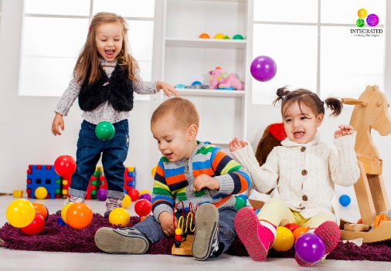
- Examples of activities
- How are these activities age appropriate
Increasingly complex play
- Examples of activities
- How are these activities age appropriate

