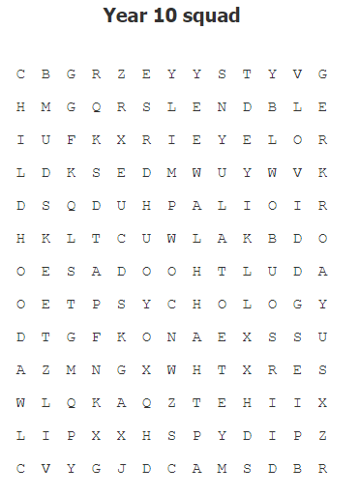

Extension: Come up with a new idea in how to help the elderly counteract loneliness. In South Korea, they’re introducing ‘day discos’ for over 60’s. What do you think?

