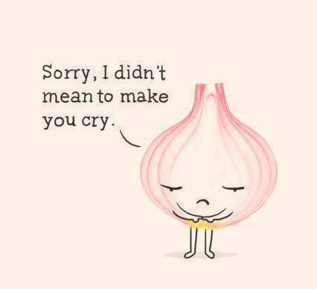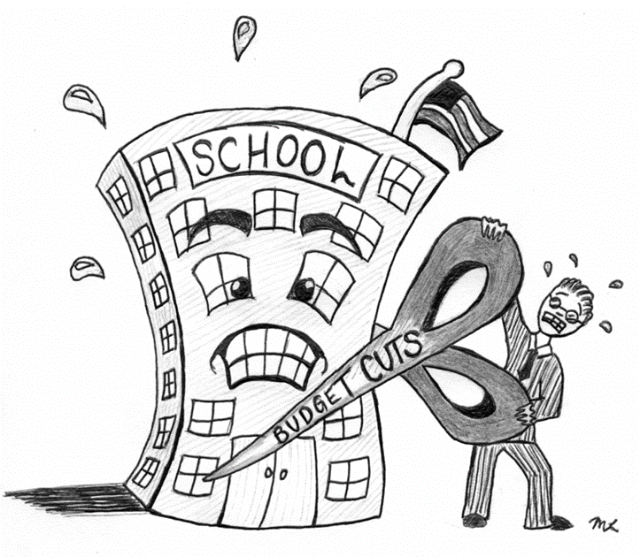



**ENGLISH**

**Year 8 Homework 11**

**Date:**

**Details:** Write a story that begins and ends with this sentence: Looking back, I didn’t mean to do it.

**Vocabulary:**

Technical Accuracy Effort Grade:

/ 4

**Peer Assessment Feedback:**

1. Highlight and label the ingredients that were given in the challenge
2. Circle any errors
3. Give a positive comment (WWW) in terms of content and structure
4. Give a target for improvement (EBI)
5. Sign and date your peer assessment

Use GREEN pen

……………………………………………………………………………………………………………………………………………………………………………………………………………………………………………………………………………………………………………………………………………………………………………………………………………………………………………………………………………………………………………………………………………………………………………………………………………………………………………………………………………………………………………………………………………………………………………………………………………………………………………………………………………………………………………………………………………………………………………………………………………………………………………………………………………………………………………………………..………………………………………………………………………………………………………………………………………………………………………………………………………………………………………………………………………………………………………………………………………………………………………………………………………………………………………………………………………………………………………………………………………………………………………………………………………………………………………………………………………………………………………………………………………………………………………………………………………………………………………………………………………………………………………………………………………………………………………………………………………………………………………………………………………………………………………

……………………………………………………………………………………………………………………………………………………………………………………………………………………………………………………………………………………………………………………………………………………………………………………………………………………………………………………………………………………………………………………………………………………………………………………………………………………………………………………………………………………………………………………………………………………………………………………………………………………………………………………………………………………………………………………………………………………………………………………………………………………………………………………………………………………………………………………………………………………………………………………………………………………………………………………………………………………………………………………………………………………………………………………………………………………………………………………………………………………………………………………………………………………………………………………………………………………………………………………………………………………………………………………

**Ingredients you need to include:**

* **Begin every paragraph with, ‘Looking back..’**
* **A metaphor**
* **A three word sentence**
* **The air was as thick as butter…**
* **Pathetic fallacy**

Name:

English Group:

Teacher: