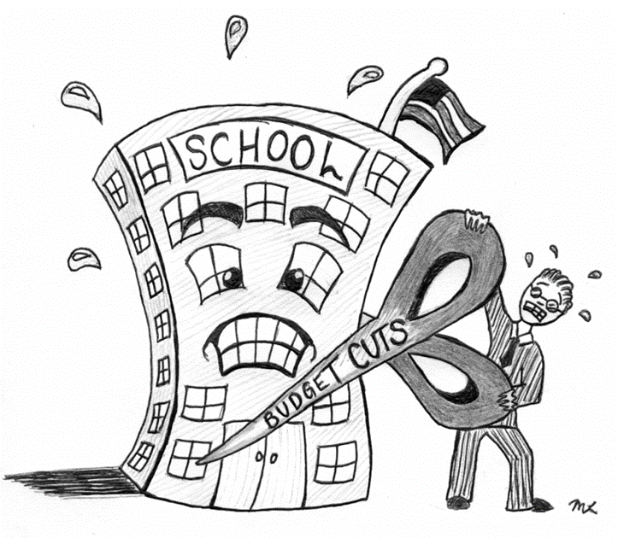



**ENGLISH**

**Year 8 Homework 12**

**Date:**

**Details:** Write a letter to a family member advising them on how to use social media effectively

**Vocabulary**

Technical Accuracy Effort Grade:

/ 4

**Peer Assessment Feedback:**

1. Highlight and label the ingredients that were given in the challenge
2. Circle any errors
3. Give a positive comment (WWW) in terms of content and structure
4. Give a target for improvement (EBI)
5. Sign and date your peer assessment

Use GREEN pen

……………………………………………………………………………………………………………………………………………………………………………………………………………………………………………………………………………………………………………………………………………………………………………………………………………………………………………………………………………………………………………………………………………………………………………………………………………………………………………………………………………………………………………………………………………………………………………………………………………………………………………………………………………………………………………………………………………………………………………………………………………………………………………………………………………………………………………………………..………………………………………………………………………………………………………………………………………………………………………………………………………………………………………………………………………………………………………………………………………………………………………………………………………………………………………………………………………………………………………………………………………………………………………………………………………………………………………………………………………………………………………………………………………………………………………………………………………………………………………………………………………………………………………………………………………………………………………………………………………………………………………………………………………………………………………

……………………………………………………………………………………………………………………………………………………………………………………………………………………………………………………………………………………………………………………………………………………………………………………………………………………………………………………………………………………………………………………………………………………………………………………………………………………………………………………………………………………………………………………………………………………………………………………………………………………………………………………………………………………………………………………………………………………………………………………………………………………………………………………………………………………………………………………………………………………………………………………………………………………………………………………………………………………………………………………………………………………………………………………………………………………………………………………………………………………………………………………………………………………………………………………………………………………………………………………………………………………………………………………

**Ingredients you need to include:**

* **Modal verbs e.g could, may, might**
* **It’s understandable that…**
* **You might be surprised to learn that..**
* **An anecdote**
* **Parenthesis ()**

Name:

English Group:

Teacher: