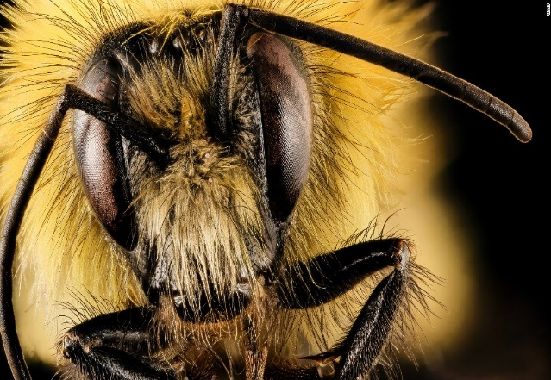

Technical Accuracy Effort Grade:

/ 4

**Peer Assessment Feedback:**

1. Highlight and label the ingredients that were given in the challenge
2. Circle any errors
3. Give a positive comment (WWW) in terms of content and structure
4. Give a target for improvement (EBI)
5. Sign and date your peer assessment

Use GREEN pen

……………………………………………………………………………………………………………………………………………………………………………………………………………………………………………………………………………………………………………………………………………………………………………………………………………………………………………………………………………………………………………………………………………………………………………………………………………………………………………………………………………………………………………………………………………………………………………………………………………………………………………………………………………………………………………………………………………………………………………………………………………………………………………………………………………………………………………………………..………………………………………………………………………………………………………………………………………………………………………………………………………………………………………………………………………………………………………………………………………………………………………………………………………………………………………………………………………………………………………………………………………………………………………………………………………………………………………………………………………………………………………………………………………………………………………………………………………………………………………………………………………………………………………………………………………………………………………………………………………………………………………………………………………………………………………

……………………………………………………………………………………………………………………………………………………………………………………………………………………………………………………………………………………………………………………………………………………………………………………………………………………………………………………………………………………………………………………………………………………………………………………………………………………………………………………………………………………………………………………………………………………………………………………………………………………………………………………………………………………………………………………………………………………………………………………………………………………………………………………………………………………………………………………………………………………………………………………………………………………………………………………………………………………………………………………………………………………………………………………………………………………………………………………………………………………………………………………………………………………………………………………………………………………………………………………………………………………………………………………

**Vocabulary:**

Advanced adjectives

1. Belligerent

2. Charismatic

3. Complacent

4. Ephemeral

5. Homogeneous

**Ingredients to Include:**

* A **Simile** to describe the colour of the walls
* **Sensory Detail**: Sound
* Your seventh sentence must **begin with a verb**
* A **triplet of adjectives**
* A one word (**minor) sentence**

Name:

English Group:

Teacher:



**ENGLISH**

**Year 7 – Autumn 2 – Homework 1**

**Date: Week Commencing October 4th 2019**

**Details:** *Describe a room from the perspective of a bee.*