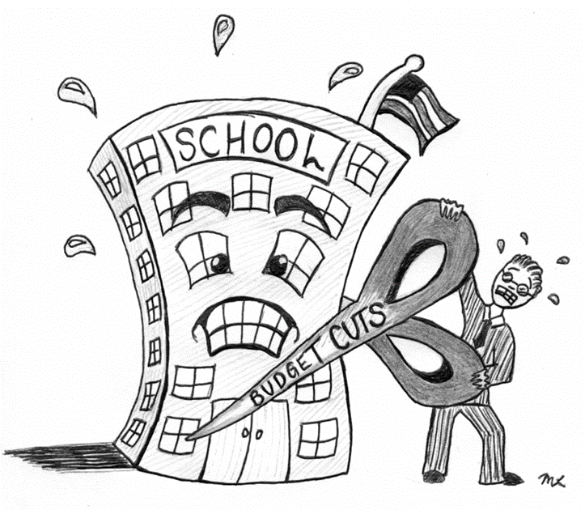



**ENGLISH**

**Year 8 – Autumn 2 – Homework 4**

**Date:**

**Details:** Write an essay on the title: My biggest fear

Technical Accuracy Effort Grade:

/ 4

**Peer Assessment Feedback:**

1. Highlight and label the ingredients that were given in the challenge
2. Circle any errors
3. Give a positive comment (WWW) in terms of content and structure
4. Give a target for improvement (EBI)
5. Sign and date your peer assessment

Use GREEN pen

……………………………………………………………………………………………………………………………………………………………………………………………………………………………………………………………………………………………………………………………………………………………………………………………………………………………………………………………………………………………………………………………………………………………………………………………………………………………………………………………………………………………………………………………………………………………………………………………………………………………………………………………………………………………………………………………………………………………………………………………………………………………………………………………………………………………………………………………..………………………………………………………………………………………………………………………………………………………………………………………………………………………………………………………………………………………………………………………………………………………………………………………………………………………………………………………………………………………………………………………………………………………………………………………………………………………………………………………………………………………………………………………………………………………………………………………………………………………………………………………………………………………………………………………………………………………………………………………………………………………………………………………………………………………………………

……………………………………………………………………………………………………………………………………………………………………………………………………………………………………………………………………………………………………………………………………………………………………………………………………………………………………………………………………………………………………………………………………………………………………………………………………………………………………………………………………………………………………………………………………………………………………………………………………………………………………………………………………………………………………………………………………………………………………………………………………………………………………………………………………………………………………………………………………………………………………………………………………………………………………………………………………………………………………………………………………………………………………………………………………………………………………………………………………………………………………………………………………………………………………………………………………………………………………………………………………………………………………………………

**Vocabulary:**

Advanced adjectives

Implacable

Insolent

Invidious

Jocular

Judicious

**Ingredients to Include:**

* **A simile to describe the object/thing of fear**
* **Conjunction: Moreover**
* **An exclamation !**
* **A rhetorical question**
* **To conclude**

Name:

English Group:

Teacher: