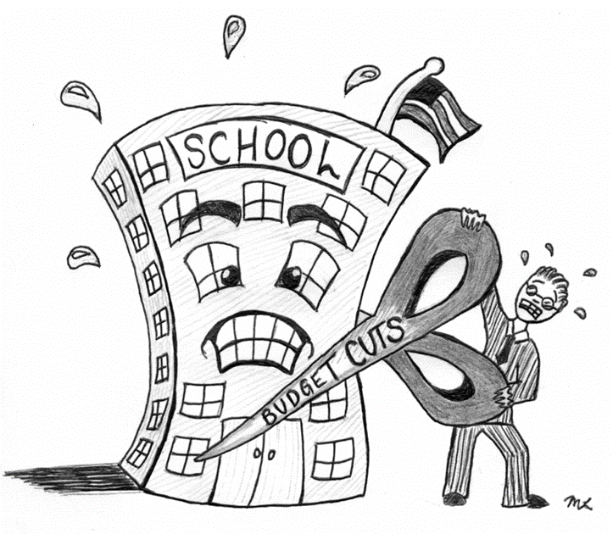



**ENGLISH**

**Year 8 – Autumn 2 – Homework 5**

**Date:**

**Details:** What is the most important colour in the world and why? Write a persuasive speech.

Technical Accuracy Effort Grade:

/ 4

**Peer Assessment Feedback:**

1. Highlight and label the ingredients that were given in the challenge
2. Circle any errors
3. Give a positive comment (WWW) in terms of content and structure
4. Give a target for improvement (EBI)
5. Sign and date your peer assessment

Use GREEN pen

……………………………………………………………………………………………………………………………………………………………………………………………………………………………………………………………………………………………………………………………………………………………………………………………………………………………………………………………………………………………………………………………………………………………………………………………………………………………………………………………………………………………………………………………………………………………………………………………………………………………………………………………………………………………………………………………………………………………………………………………………………………………………………………………………………………………………………………………..………………………………………………………………………………………………………………………………………………………………………………………………………………………………………………………………………………………………………………………………………………………………………………………………………………………………………………………………………………………………………………………………………………………………………………………………………………………………………………………………………………………………………………………………………………………………………………………………………………………………………………………………………………………………………………………………………………………………………………………………………………………………………………………………………………………………………

……………………………………………………………………………………………………………………………………………………………………………………………………………………………………………………………………………………………………………………………………………………………………………………………………………………………………………………………………………………………………………………………………………………………………………………………………………………………………………………………………………………………………………………………………………………………………………………………………………………………………………………………………………………………………………………………………………………………………………………………………………………………………………………………………………………………………………………………………………………………………………………………………………………………………………………………………………………………………………………………………………………………………………………………………………………………………………………………………………………………………………………………………………………………………………………………………………………………………………………………………………………………………………………

**Vocabulary:**

**Advanced nouns**

Faux pas

Gravitas

Infancy

Interlude

Invective

**Ingredients to Include:**

* **Pronouns we/our/your**
* **Imagine if…**
* **A statistic**
* **In your second paragraph every sentence must begin with the same word or phrase**

Name:

English Group:

Teacher: