Q1.
(a) Diagram 1 shows two waves.
Diagram 1
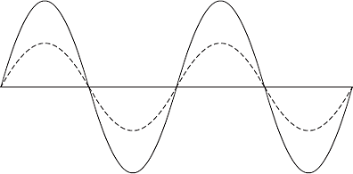
(i) Name one wave quantity that is the same for the two waves.
______________________________________________________________ (1)
(ii) Name one wave quantity that is different for the two waves.
______________________________________________________________ (1)
(iii) The waves in Diagram 1 are transverse.
Which one of the following types of wave is not a transverse wave?
Draw a ring around the correct answer.

gamma rays | sound | visible light
(1)
(b) Diagram 2 shows water waves in a ripple tank moving towards and passing through a gap in a barrier.
Diagram 2
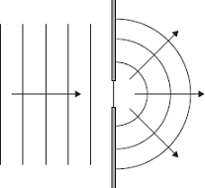
Every second, 8 waves pass through the gap in the barrier. The waves have a wavelength of 0.015 metres.
Calculate the speed of the water waves and give the unit.
___________________________________________________________________
___________________________________________________________________
___________________________________________________________________
Speed = ___________________________________
(3)
(Total 6 marks)
Q2.
(a) Write down the equation that links frequency, wave speed and wavelength.
Equation ___________________________________________________________ (1)
(b) The signals for the monitor unit are transmitted as electromagnetic waves with a wavelength of 0.125 m.
Wave speed of electromagnetic waves = 3 × 10⁸ m / s
Calculate the frequency of the signal.
___________________________________________________________________
___________________________________________________________________
___________________________________________________________________
___________________________________________________________________
Frequency = __________________ Hz (3)
(Total 4 marks)
Q3.
A sound wave is an example of a longitudinal wave.
(a) Figure 1 shows the air particles in a sound wave as the wave travels from a loudspeaker to an ear.
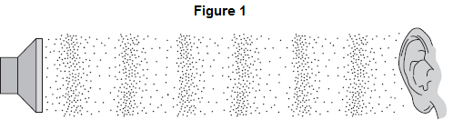
Write a letter R on Figure 1 to show an area of rarefaction.
(1)
(b) Complete the sentence about longitudinal waves.
The vibrations of the air particles are __________________________ to the direction of energy transfer.
(1)
(c) A stationary car horn emits a sound wave of frequency 400 Hz.
The wavelength of the wave is 0.85 m.
Calculate the speed of sound.
Use the correct equation from the Physics Equations Sheet.
___________________________________________________________________
___________________________________________________________________
___________________________________________________________________
Speed of sound = _________________ m / s
(2)
(Total 4 marks)

