Q1.
The diagram shows a ripple tank.
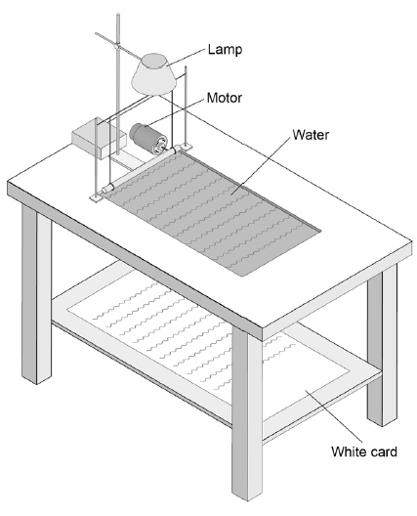
(a) The motor makes a noise when it is turned on.
Describe the differences between the properties of the sound waves produced by the motor and the water waves in the ripple tank.
___________________________________________________________________
___________________________________________________________________
___________________________________________________________________
___________________________________________________________________
___________________________________________________________________
___________________________________________________________________
___________________________________________________________________
___________________________________________________________________
(4)
(b) The period of the sound waves produced by the motor is 8.3 milliseconds.
Calculate the frequency of the sound waves.

Period = 1 ÷ frequency
___________________________________________________________________
___________________________________________________________________
___________________________________________________________________
___________________________________________________________________
___________________________________________________________________
___________________________________________________________________
Frequency = ____________________ Hz
(3)
(c) Explain how a student could make appropriate measurements and use them to determine the wavelength of the waves in the ripple tank.
___________________________________________________________________
___________________________________________________________________
___________________________________________________________________
___________________________________________________________________
___________________________________________________________________
___________________________________________________________________
___________________________________________________________________
___________________________________________________________________
___________________________________________________________________
___________________________________________________________________
___________________________________________________________________
___________________________________________________________________
___________________________________________________________________
___________________________________________________________________
___________________________________________________________________
___________________________________________________________________
(6)
(Total 13 marks)

