Q1.
Human cells and yeast cells have some parts that are the same.
(a) The diagram shows a yeast cell.
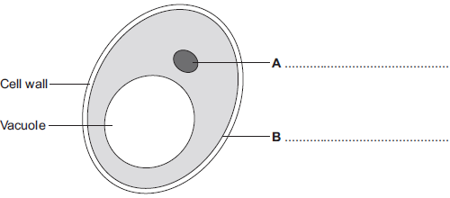
Parts A and B are found in human cells and in yeast cells. On the diagram, label parts A and B.
(2)
(b) Many types of cell can divide to form new cells.
Some cells in human skin can divide to make new skin cells.
Why do human skin cells need to divide?
___________________________________________________________________
___________________________________________________________________ (1)
(c) Human stem cells can develop into many different types of human cell.
(i) Use the correct answer from the box to complete the sentence.

embryos | hair | nerve cells
Human stem cells may come from
______________________________________________________________ (1)
(ii) Use the correct answer from the box to complete the sentence.

cystic fibrosis | paralysis | polydactyly
Human stem cells can be used to treat
______________________________________________________________ (1)
(Total 5 marks)
Q2.
Cells in the human body are specialised to carry out their particular function.
(a) The diagram shows a sperm cell.
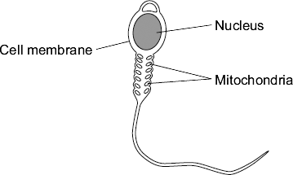
The sperm cell is adapted for travelling to, then fertilising, an egg.
(i) How do the mitochondria help the sperm to carry out its function?
______________________________________________________________
______________________________________________________________
(1)
(ii) The nucleus of the sperm cell is different from the nucleus of body cells.
Give one way in which the nucleus is different.
______________________________________________________________
______________________________________________________________
(1)
(b) Stem cells from human embryos are used to treat some diseases in humans.
Explain why.
___________________________________________________________________
___________________________________________________________________
___________________________________________________________________
___________________________________________________________________
(2)
(Total 4 marks)
Q3.
The diagram shows how cells from human embryos can be used to grow ‘replacement body parts’ for humans.
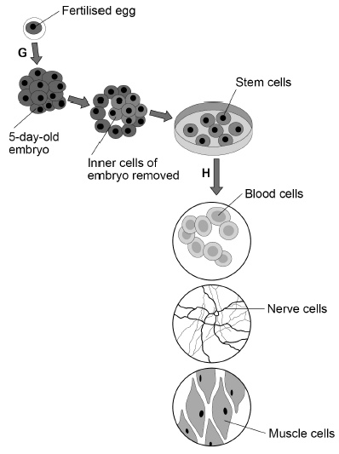
(a) How many chromosomes are in a fertilised human egg?
Tick one box.

12 |  | 23 |  | 46 |  | 92
(1)
(b) What is the process labelled G?
Tick one box.

Fertilisation
Inheritance
Meiosis
Mitosis
(1)
(c) When the embryo is three days old, it contains eight cells.
How many times has the fertilised egg cell divided by day three?
Tick one box.

2 |  | 3 |  | 4 |  | 8
(1)
(d) Stem cells become specialised in the process labelled H in the diagram.
What is the process labelled H?
Tick one box.

Differentiation
Evolution
Genetic modification
Selective breeding
(1)
(e) Which two parts would be found in all the cells in the diagram.
Tick two boxes.

Cell membrane
Cell wall
Chloroplasts
Cytoplasm
Plasmids
(2)
(f) Why might stem cells from human embryos be more useful than stem cells from adults?
___________________________________________________________________
___________________________________________________________________
(1)

(g) Some parents have stem cells from the umbilical cord of their baby collected and stored.
These stem cells can be used to treat diseases in the child later in life.
Why might stem cells from their own umbilical cord be used rather than stem cells from another embryo?
Tick one box.

Less risk of rejection of umbilical cord stem cells.
Stem cells from another embryo can treat more diseases.
Umbilical cord stem cells are older.
(1)
(h) Some medical uses of stem cells are still experimental.
Why do some scientists have concerns about the use of stem cells?
___________________________________________________________________
___________________________________________________________________
(1)
(i) Some people object to the use of embryonic stem cells because of religious beliefs.
Give one other ethical concern about the use of embryonic stem cells?
___________________________________________________________________
___________________________________________________________________
(1)
(Total 10 marks)

