Q1.
Ben makes a series circuit using two identical cells, a bulb and a switch to turn the bulb on and off.
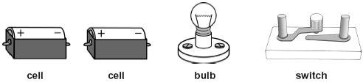
(a) Draw a circuit diagram of Ben’s circuit. Use the correct symbols.
The cells have been drawn for you.
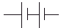

3 marks
(b) Which part of the circuit supplies the energy?
......................................................................................................................
1 mark
(c) Ben adds another identical bulb to the circuit in series.
How does the brightness of the first bulb change?
......................................................................................................................
1 mark

(d) How will the brightness of the bulbs change when the cells shown below are placed into Ben’s circuit?
(i)
.............................................
1 mark
(ii) 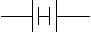
.............................................
1 mark
maximum 7 marks
Q2.
(a) Max built circuit 1 as shown below.
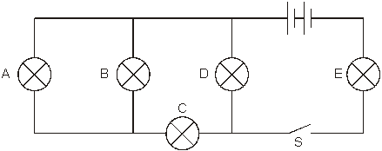
circuit 1
He closed the switch, S, and all the bulbs came on.
One of the bulbs then broke and all the bulbs went off.
Which bulb must have broken?
Give the letter.
...............
1 mark
(b) Max built circuit 2 as shown below.
He connected a plastic comb and a metal key in different parts of the circuit.
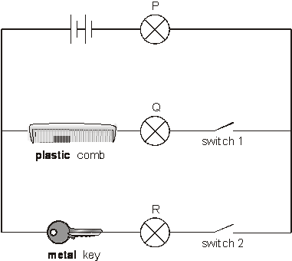
circuit 2
Look carefully at circuit 2.
Complete the table below to show which bulbs in circuit 2 will be on or off when
different switches are open or closed.
Write on or off in the boxes below.

switch 1 | switch 2 | bulb P | bulb Q | bulb R
open | open | off | off | off
open | closed
closed | open
2 marks
(c) Max built circuit 3 using a battery, two bulbs and three ammeters.
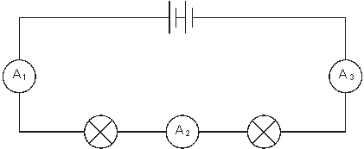
circuit 3
The current reading on ammeter A₁ was 0.8 amps.
What would be the reading on ammeters A₂ and A₃?
Place one tick in the table by the correct pair of readings.

readingon reading on  ammeter A₂ (amps) ammeter A₃ (amps) | correct pair of readings
0.8 0.8
0.8 0.4
0.4 0.8
0.4 0.4
1 mark
maximum 4 marks

