Q1.
David put two bars of iron close to each other.
There was no magnetic force between them.
David recorded the result as shown below.
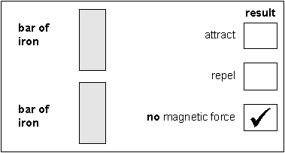
(a) David did three other tests.
Tick the correct box to show the result for each test.
(i)
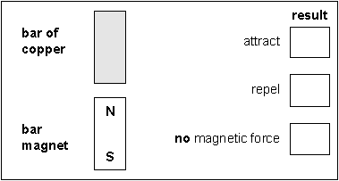
1 mark
(ii)
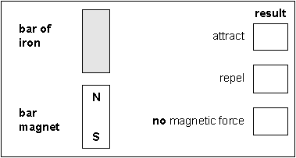
1 mark
(iii)
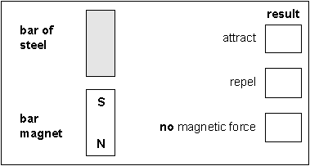
1 mark
(b) David then did two experiments with magnets.
The tick in each box shows David’s results in each experiment.
Label the missing poles on each magnet to match David’s results.
(i)
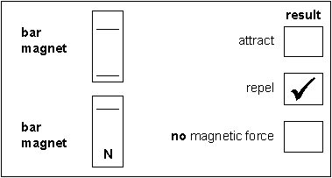
1 mark
(ii)
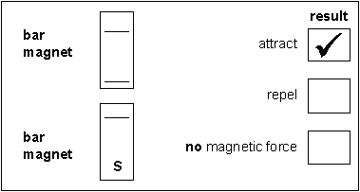
1 mark
maximum 5 marks
Q2.
The diagram below shows three trolleys.
Peter put a bar magnet on each trolley.
(a) He pushed trolleys A, B and C together.
• Magnet B attracted magnet A.
• Magnet B repelled magnet C.
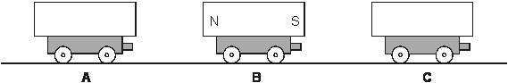
On the diagram above, label the north and south poles of
magnets A and C.
Use the letters N and S.
2 marks
(b) Peter turned trolley B around. Trolleys A and C were not turned around.
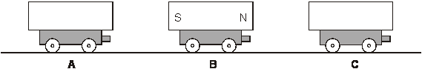
What would happen now when Peter pushed them all together?
Use either attract or repel to complete each sentence below.
Magnet B would .................................... magnet A.
Magnet B would .................................... magnet C.
1 mark
(c) Peter held two trolleys close together and then let go.
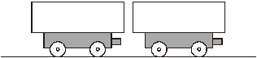
The magnets repelled each other.
Draw an arrow on both magnets to show which way they would move.
1 mark

(d) Peter took a magnet, a steel bar and an aluminium bar.
He put them on three trolleys as shown below.
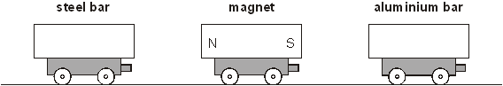
(i) What happens to the steel bar as he moves it closer to the magnet?
...............................................................................................................
1 mark
(ii) What happens to the aluminium bar as he moves it closer to the magnet?
...............................................................................................................
1 mark
maximum 6 marks

