Q1.
This question is about stem cells.
(a) Give one place in a plant where stem cells are found.
___________________________________________________________________
___________________________________________________________________
(1)
(b) What is one economic use of plant stem cells?
Tick one box.

To create genetically modified crops
To create new species of plants
To increase variation in plants
To produce large numbers of identical plants
(1)
Embryonic stem cells divide by mitosis.
Figure 1 represents a cell cycle for a human embryonic stem cell.
Figure 1
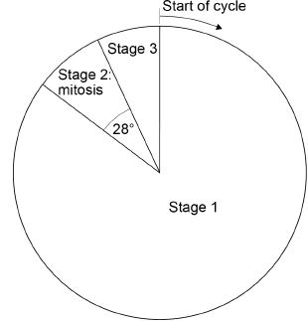
(c) The mass of DNA in the cell at the start of the cycle is 6 picograms.
A picogram is 10⁻³ nanograms.
Convert 6 picograms to grams.
Give your answer in standard form.
___________________________________________________________________
___________________________________________________________________
Mass = _____________________ g (1)
(d) The time taken for this complete cell cycle is 15 hours.
Calculate how many hours the cell spent in mitosis.
Give your answer to 3 significant figures.
___________________________________________________________________
___________________________________________________________________
___________________________________________________________________
___________________________________________________________________
Time spent in mitosis = _____________________ hours
(2)
(e) Describe what happens in each of the three stages of the cell cycle.
___________________________________________________________________
___________________________________________________________________
___________________________________________________________________
___________________________________________________________________
___________________________________________________________________
___________________________________________________________________
___________________________________________________________________
___________________________________________________________________
___________________________________________________________________
___________________________________________________________________
___________________________________________________________________
___________________________________________________________________ (5)
(Total 10 marks)

