Q1.
Osmosis is the movement of water through partially permeable cell membranes.
A group of students investigated the effect of temperature on the rate of osmosis in potato cells. The students used five potato chips all cut to the same size.
Figure 1 shows one chip.
Figure 1
This is the method used.
1. Half fill a boiling tube with distilled water.
2. Heat the water to 25 °C
3. Place one potato chip in the boiling tube.
4. Keep the boiling tube and potato chip at 25 °C for 30 minutes.
5. Repeat steps 1−4 at four other temperatures.
(a) All of the potato chips gained water by osmosis.
Explain how the students would find out the rate of water uptake by osmosis in each potato chip.
___________________________________________________________________
___________________________________________________________________
___________________________________________________________________
___________________________________________________________________
___________________________________________________________________
___________________________________________________________________
(3)
(b) One of the students used a knife to cut the potato chips.
Suggest how the student could improve the method of cutting the potato chips to make sure they are all the same size.
___________________________________________________________________
___________________________________________________________________
(1)
(c) Another student cut their potato chips as shown in Figure 2.
Figure 2
Suggest how the rate of water uptake by osmosis in this investigation was different from the investigation with the chips shown in Figure 2.
Give a reason for your answer.
___________________________________________________________________
___________________________________________________________________
___________________________________________________________________
___________________________________________________________________
(2)
(d) The students carried out the experiment at 25 °C, 30 °C, 35 °C, 40 °C and 45 °C
Predict what you would expect the results to show as the temperature increases.
Give a reason for your answer.
Prediction __________________________________________________________
___________________________________________________________________
Reason ____________________________________________________________
___________________________________________________________________
(2)
(Total 8 marks)
Q2.
Figure 1 shows part of the lungs.
Figure 1: 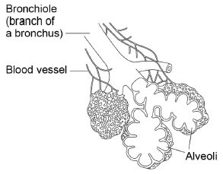
(a) Give two ways the lungs are adapted for efficient exchange of gases.
Describe how each adaptation helps to maintain efficient gas exchange.
Adaptation 1 ________________________________________________________
___________________________________________________________________
Description _________________________________________________________
___________________________________________________________________
Adaptation 2 ________________________________________________________
___________________________________________________________________
Description _________________________________________________________
___________________________________________________________________ (4)
(b) There are 5.4 million people with asthma in the UK.
What type of disease is asthma?
Tick one box.

An allergy
A bacterial infection
A cancer
A viral infection
(1)
(c) Figure 2 shows cross-sections of bronchioles of two people.
Figure 2
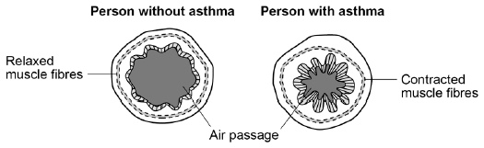
Suggest why people with asthma often find it difficult to breathe.
___________________________________________________________________
___________________________________________________________________
(1)
(d) People with asthma often have a reduced lung volume.
Figure 3 shows the apparatus a student used to measure his lung volume.
Figure 3
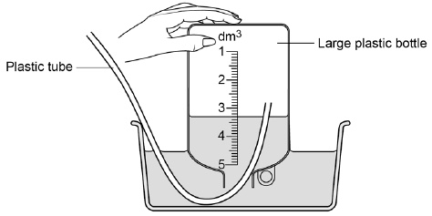
This is the method used.
1 Fill the bottle with water.
2 Breathe out through the tube.
The volume of water pushed out of the bottle is equal to his lung volume.
What is the student’s lung volume?
Volume = ____________________ dm³
(1)
(Total 7 marks)
Q3.
The table shows the concentrations of three mineral ions in the roots of a plant and in the water in the surrounding soil.

Mineral ion | Concentration in millimoles per kilogram
 | Plant root | Soil
Calcium | 120 | 2.0
Magnesium | 80 | 3.1
Potassium | 250 | 1.2
(a) (i) The plant roots could not have absorbed these mineral ions by diffusion.
Explain why.
______________________________________________________________
______________________________________________________________
______________________________________________________________
______________________________________________________________ (2)
(ii) Name the process by which the plant roots absorb mineral ions.
______________________________________________________________ (1)
(b) How do the following features of plant roots help the plant to absorb mineral ions from the soil?
(i) A plant root has thousands of root hairs.
______________________________________________________________
______________________________________________________________ (1)
(ii) A root hair cell contains many mitochondria.
______________________________________________________________
______________________________________________________________
______________________________________________________________
______________________________________________________________ (2)
(iii) Many of the cells in the root store starch.
______________________________________________________________
______________________________________________________________ (1)
(Total 7 marks)

